Data Analytics Mini Project 1
Project Title- amazon sales&ecommerce mini project-1 after cleaning

For excel report

NAME:Abinaya Mondal

Date Of Submission:12/08/2026

Raw data-amazon retail sales raw data for mini project 1

Raw data source-https://datasetsearch.research.google.com/search?src=3&query=amazon%20sales%20dataset&docid=L2cvMTF5cnNyY2Z0Xw%3D%3D
For excel report
Link:amazon sales ^0ecommerce mini project-1 after cleaning.xlsx

Amazon sales report page 02-23

For power bi report
Link:amazon retail sales report on mini project.pbix

Amazon sales report page 23-37

1. Data Pre-processing using Excel

○ Perform cleaning and transformation tasks on raw data, such as:

- First i have to clean my data as per excel cleaning process

- At start I create a table format for data ,my data source contains 1500 data,so table creation makes the data source clean and neat.
BEFORE
SCREENSHOT
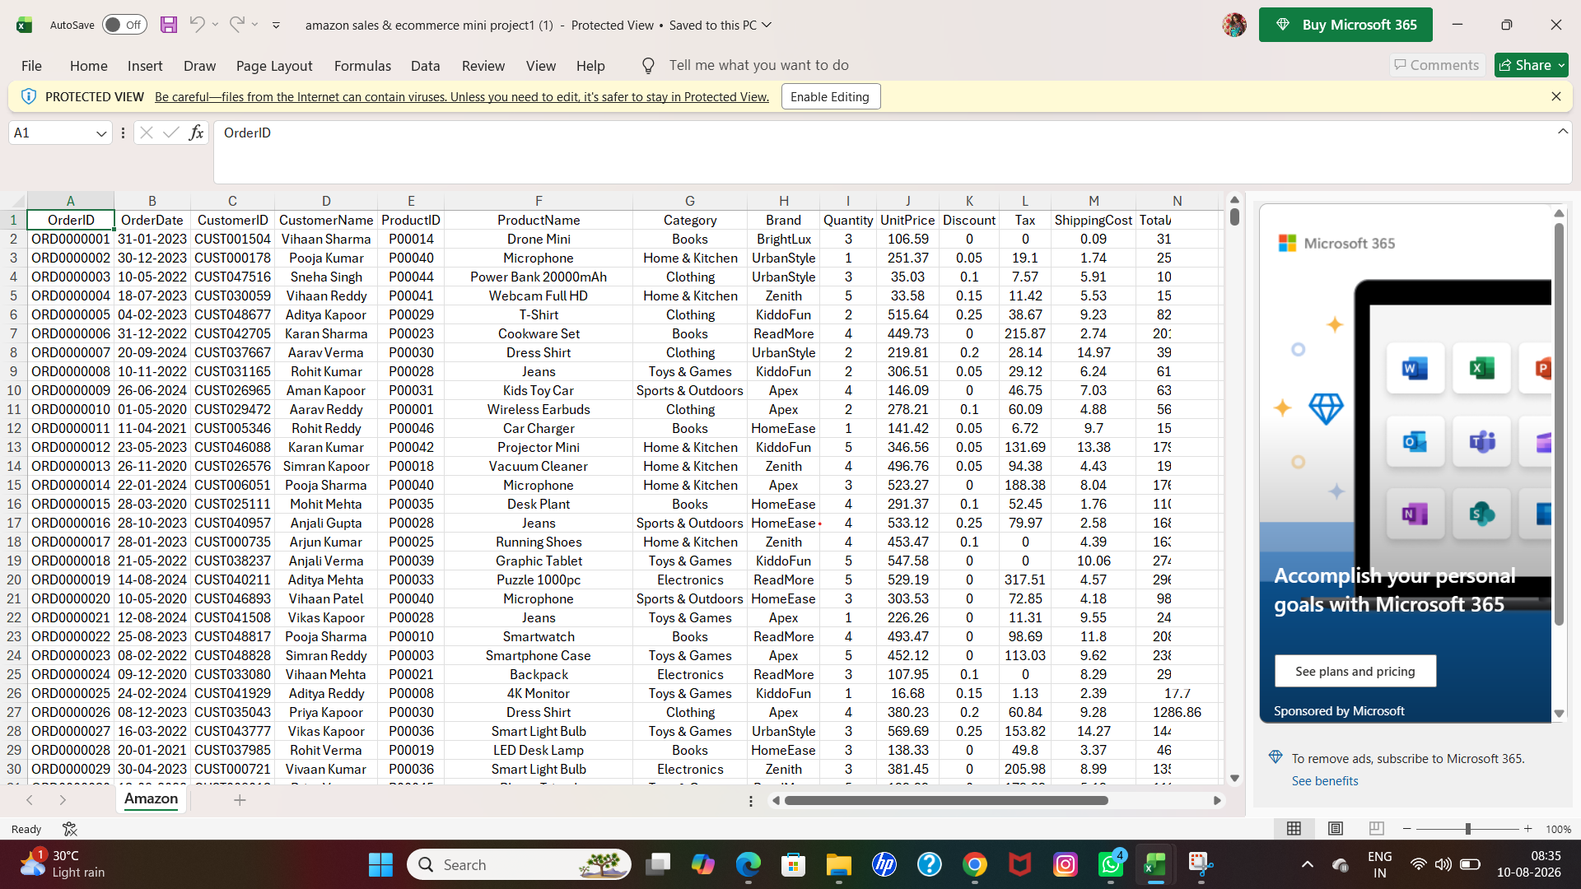
AFTER
SCREENSHOT

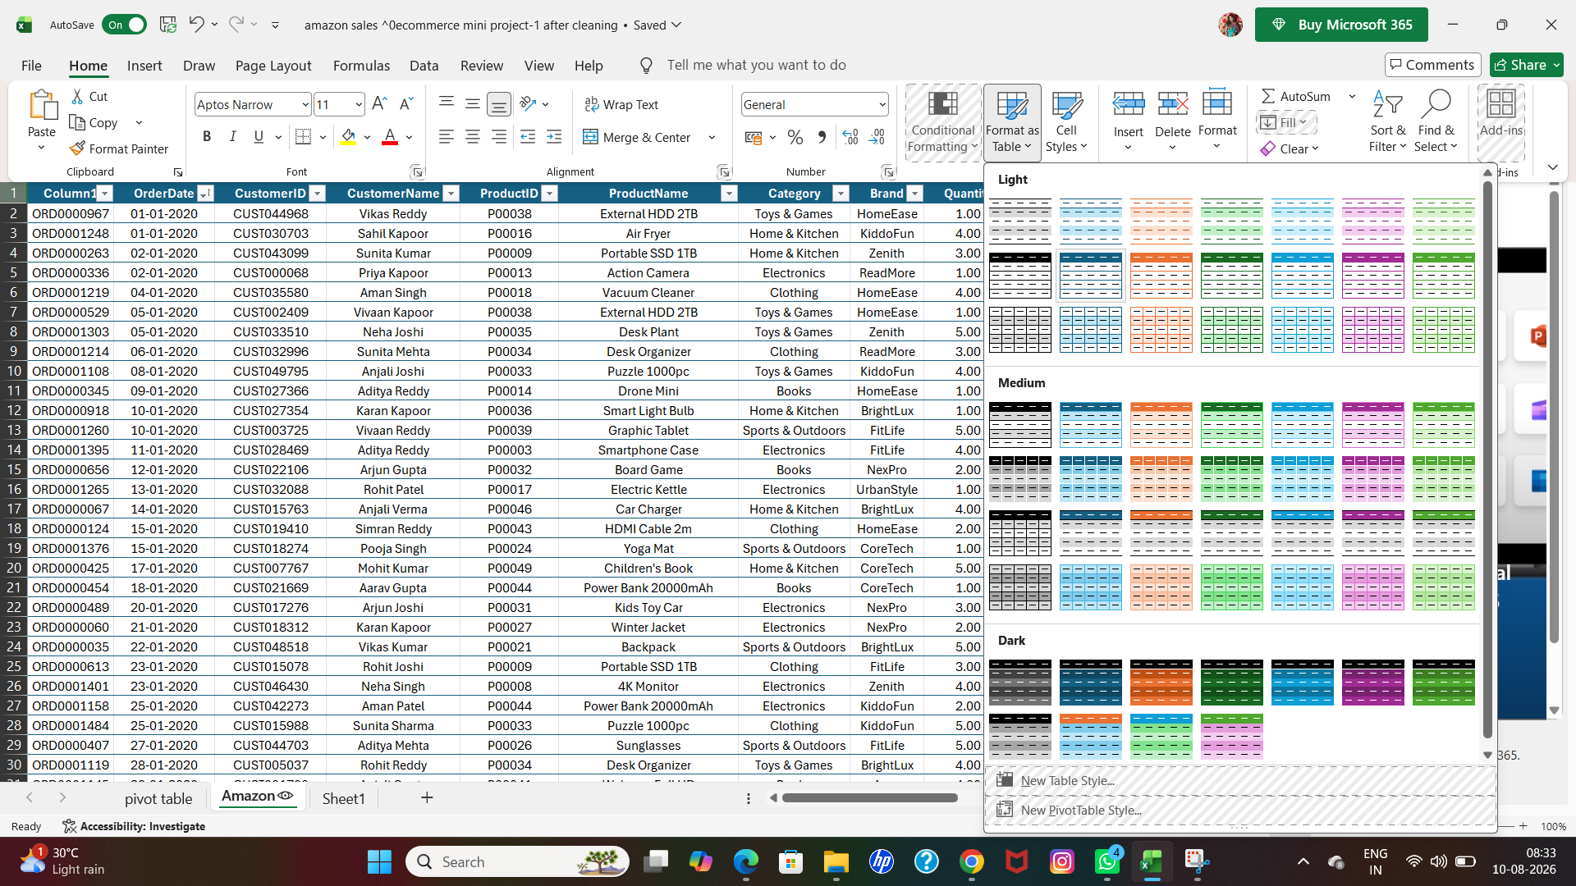

- Then I had to adjust the font size for my full table,because it is so messy,so I adjusted to 10 of all font sizes by selecting the table ctrl+A.then go to home tab-font size-10.

BEFORE
SCREENSHOT


AFTER
SCREENSHOT

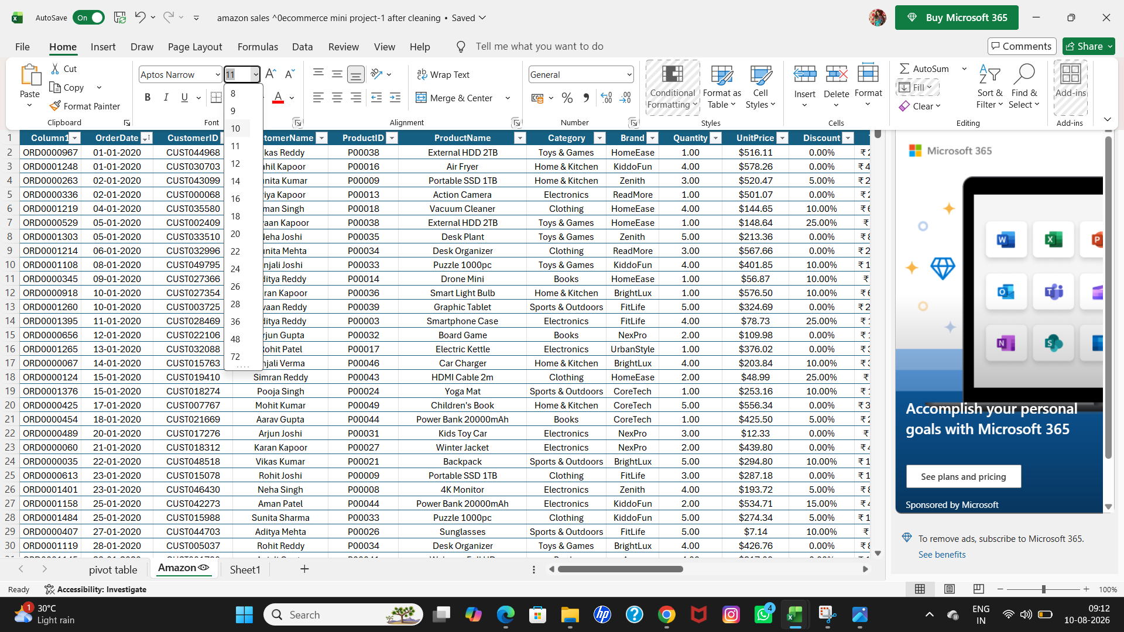

- Then i had to adjust the row and column by selecting data
- ctrl+A-home-format-autofit row height
- ctrl+A-home-format-autofit column width

BEFORE
SCREENSHOT



AFTER
SCREENSHOT

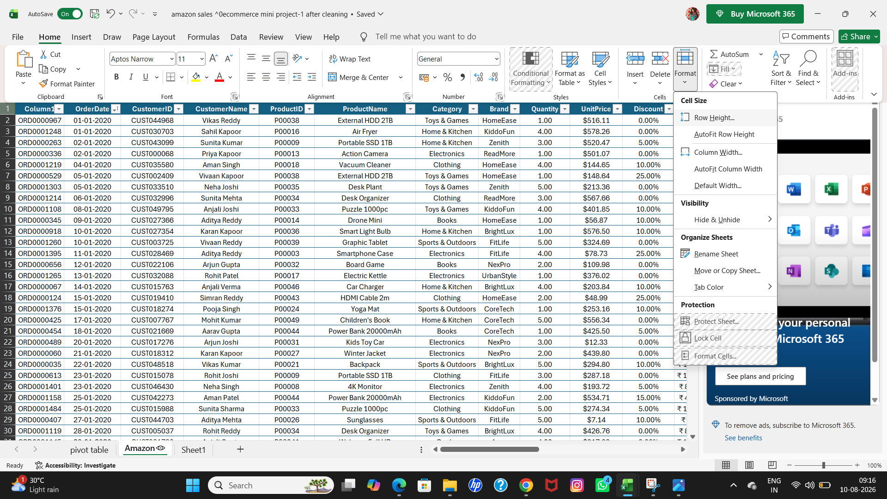

Q1■ Removing duplicates

- After the basic processing of cleaning data,i had to find & remove duplicate data.
- Go to ctrl+A for selecting data table
- Then go to data-select remove duplicate,a box open
- Select all columns+select my data has headers ,click ok.
- If any duplicates are there ,it is shown,but I had no duplicate so.
- It is also shown very clearly on display.

SCREENSHOT

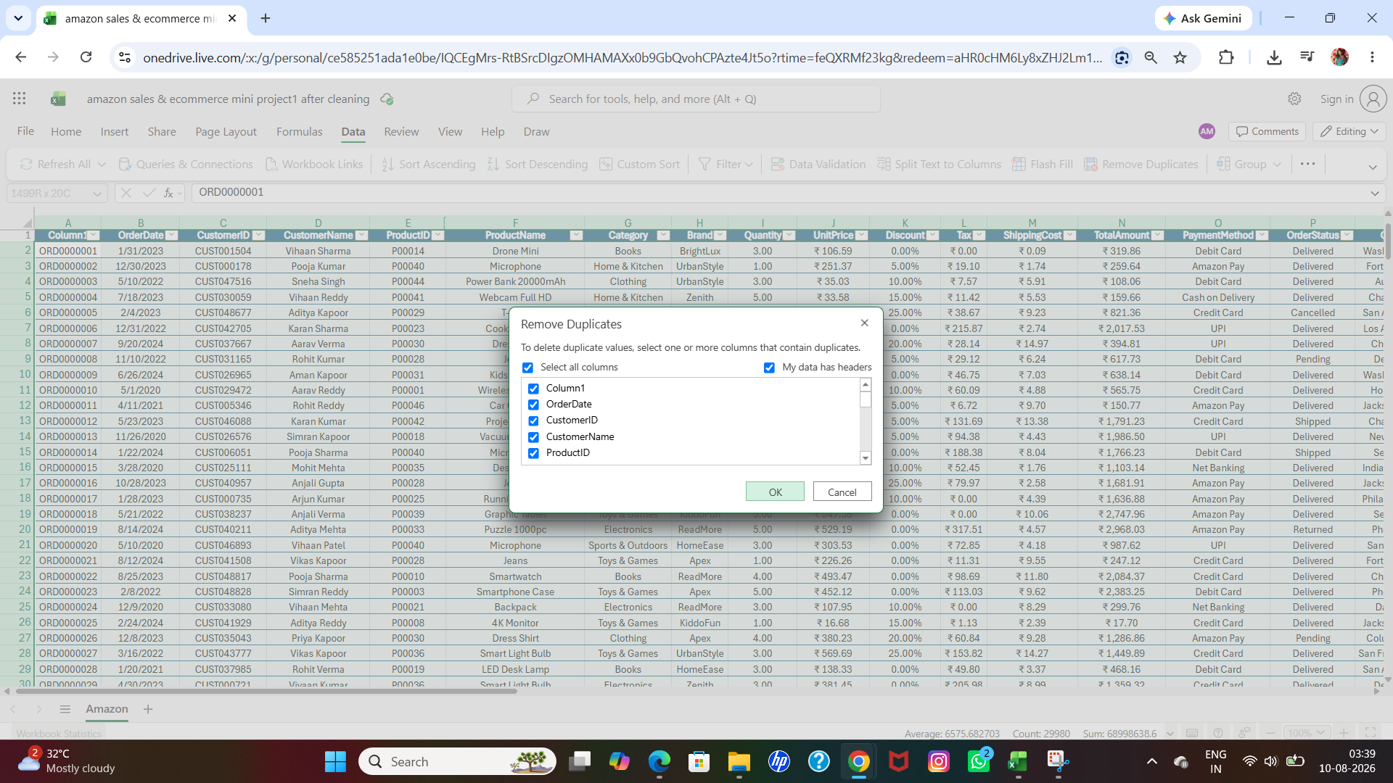

SCREENSHOT

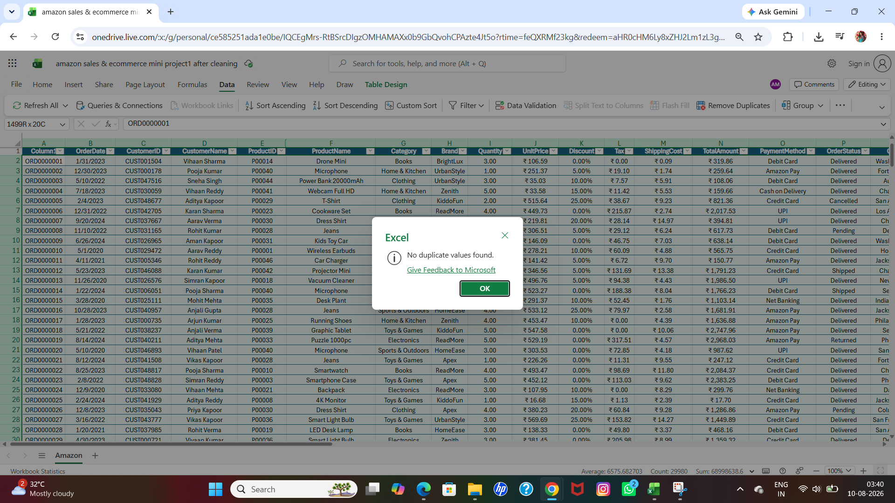

Q2■ Handling missing values

- For finding missing values,i had to select all the data by click ctrl+A
- Then go to home -find&select-go to special
- Click blank -click ok
- There are no blank values ,that means no missing values.

SCREENSHOT

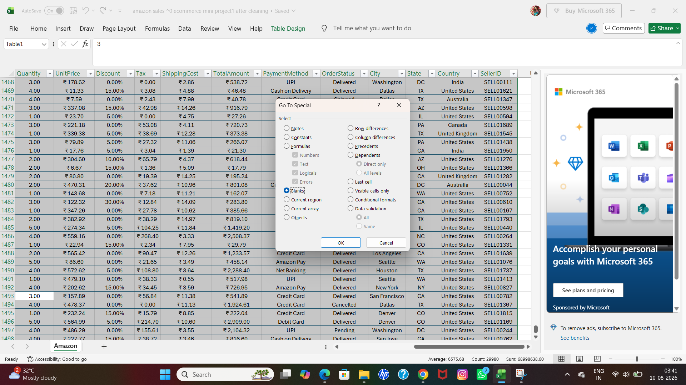

SCREENSHOT

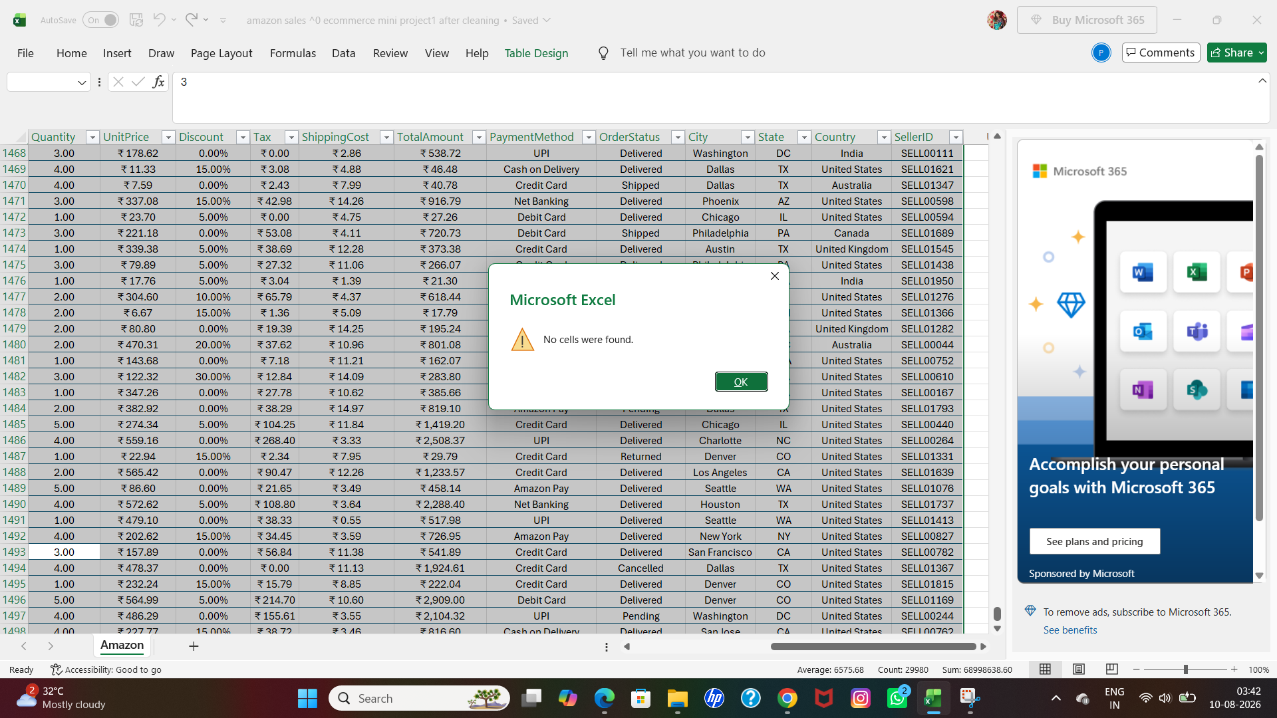

Q3■ Standardizing formats

- My data table has 17 columns,every column has a text and number formats so I had to find and replace their formatting as per the standard.
- Ctrl+space For selecting the column one by one by click,
- Then go to the home-select formatting option.
- If the column data has letters ,then choose text
- If the column data has numbers like amount choose currency
- If the column data has numbers like Discount, then choose percentage.
- If the column data has date,then choose time.

SCREENSHOT

Date Formating

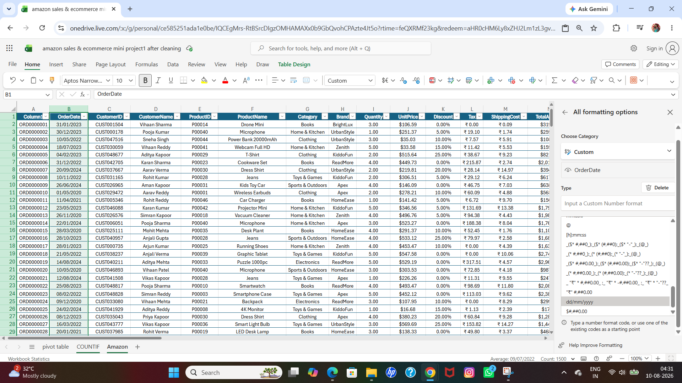

SCREENSHOT

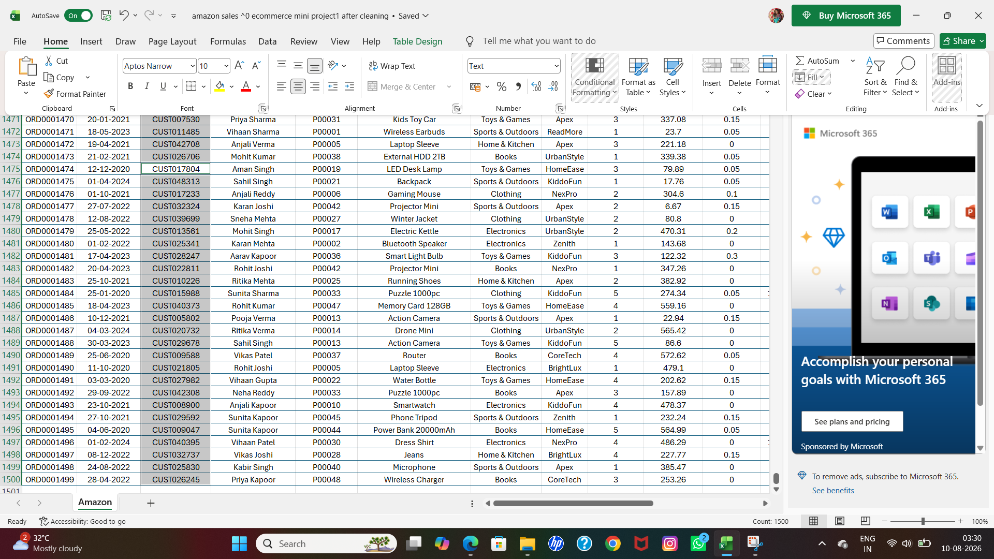

Q4■ Creating calculated fields (if required)

- I had to do some of calculated columns for the record
- First, i had to calculate the total value of the sales
- Formula that i ad given is =SUM(N2:N1500)
- The result is shown

SCREENSHOT

- 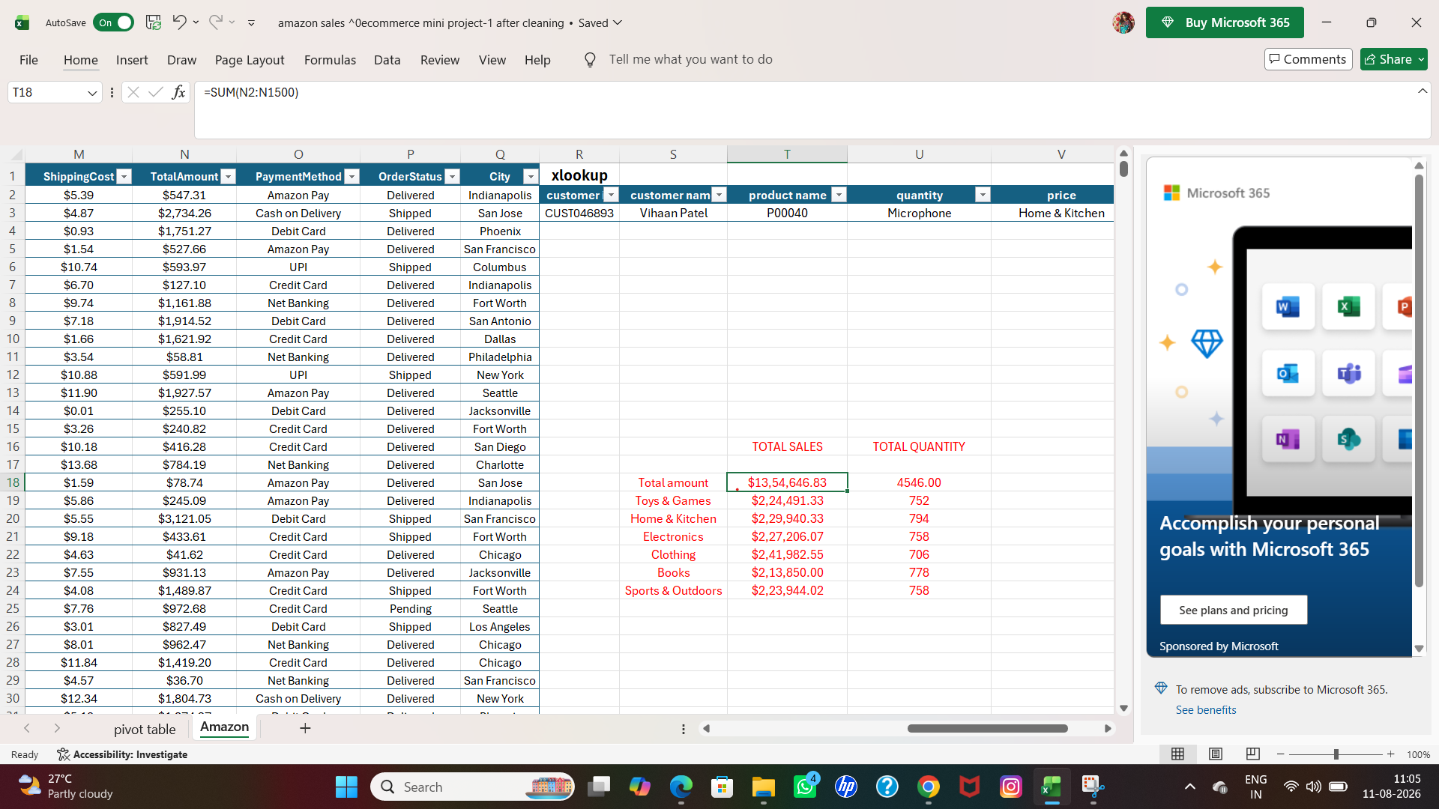

- Then i had to calculate the total quantity of sales
- The formula i had given is =SUM(I2:I1500)
- Then the result is shown

SCREENSHOT

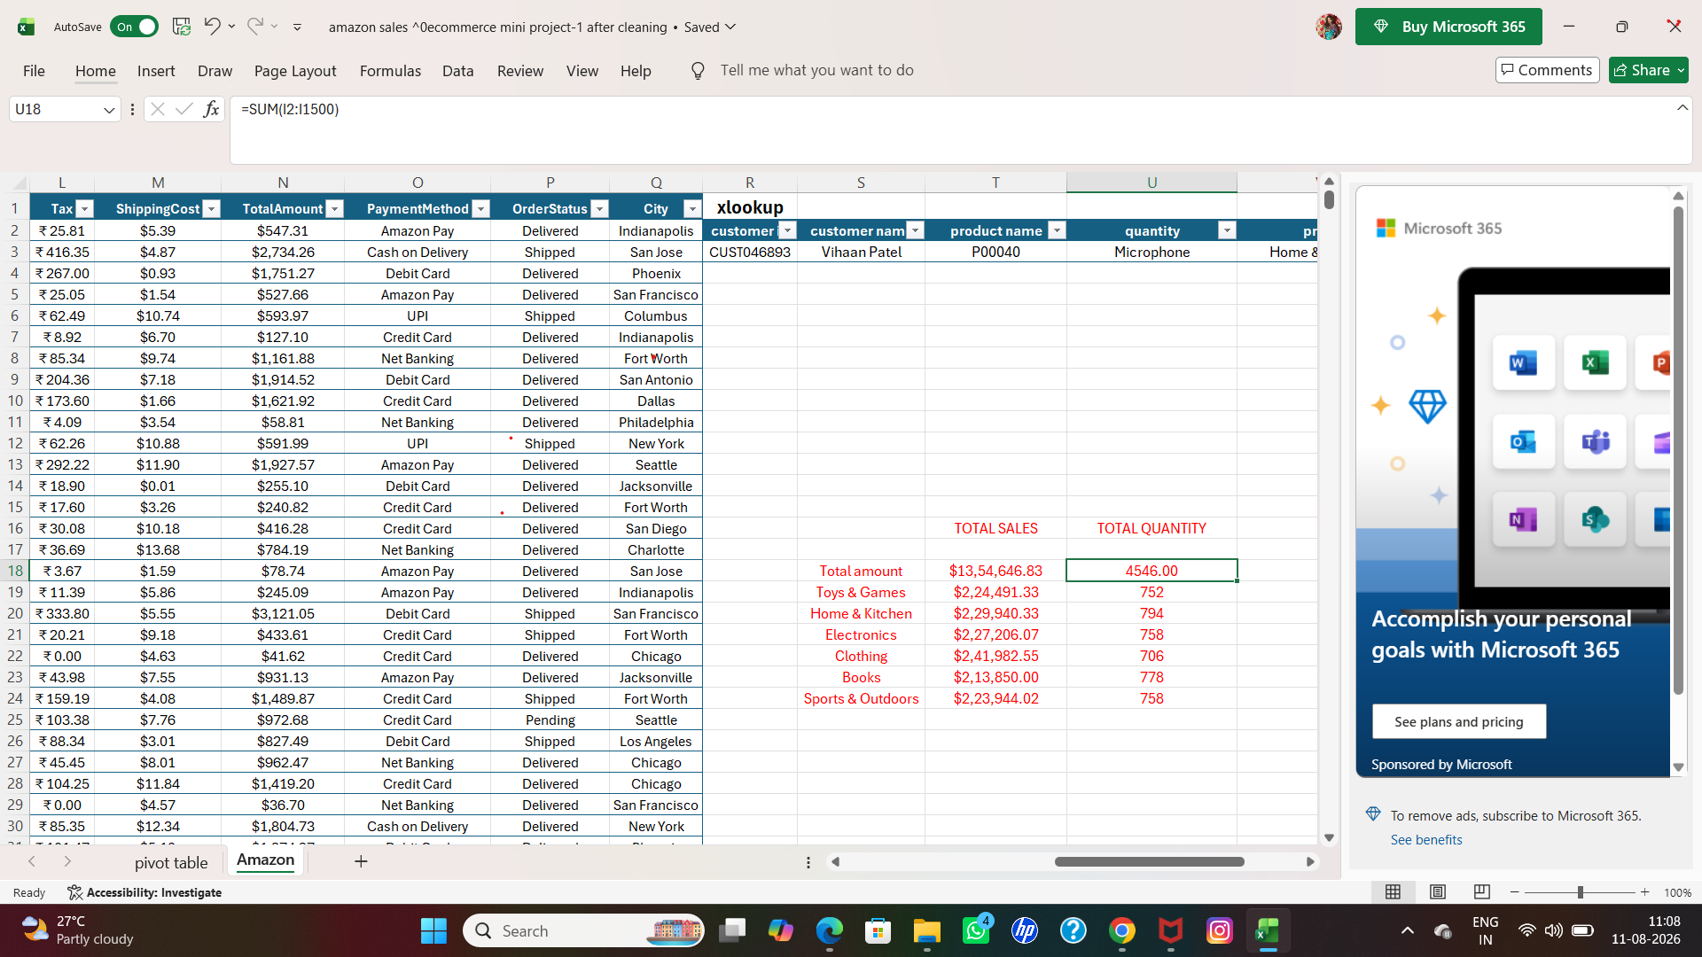

- In category column,there are many types of product category is shown,at first i had to ascending the category by the formula
- The formula is =UNIQUE(G2:G1500)
- Then result is shown

SCREENSHOT

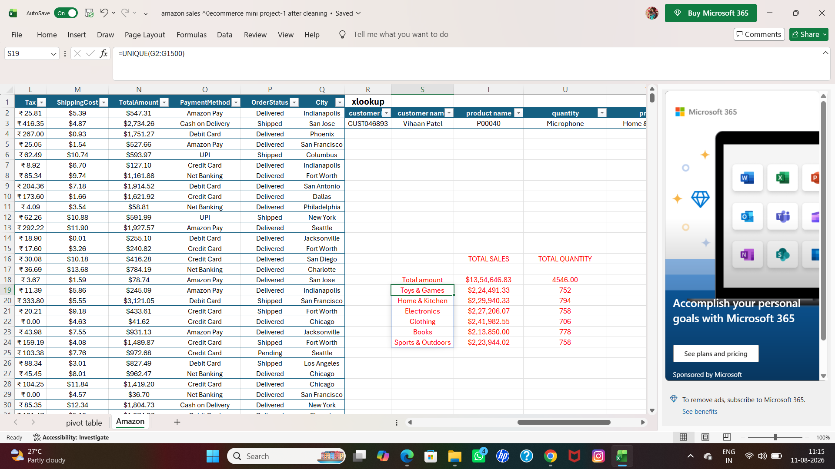

- After ascending my category separately in order ,
- i had to calculate the total number of sales according to the category type
- The formula is =SUMIF(G2:G1500,G2,N2:N1500)

SCREENSHOT

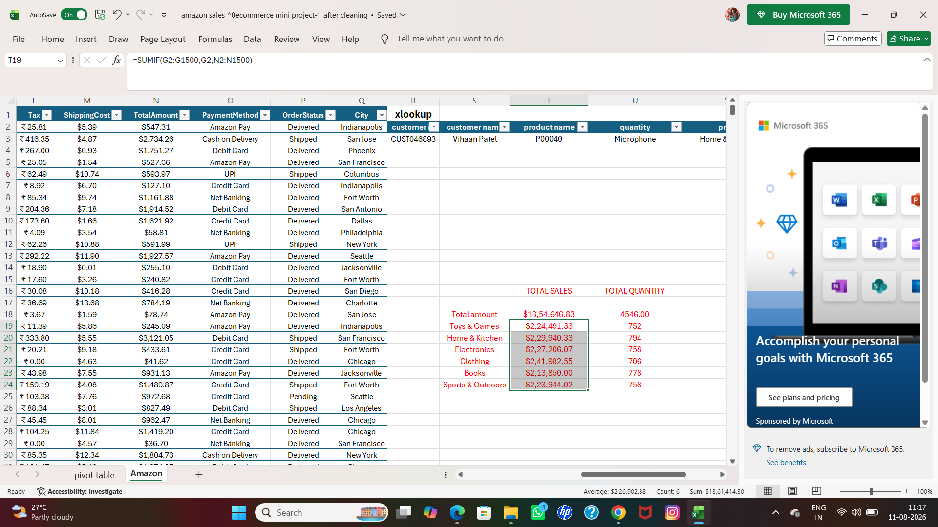

- Then i had to calculate total of quantity ,in order to the category type

- So the formula i had given is =SUMIF(G2:G1500,S19,I2:I1500)
- Then the result is shown

SCREENSHOT

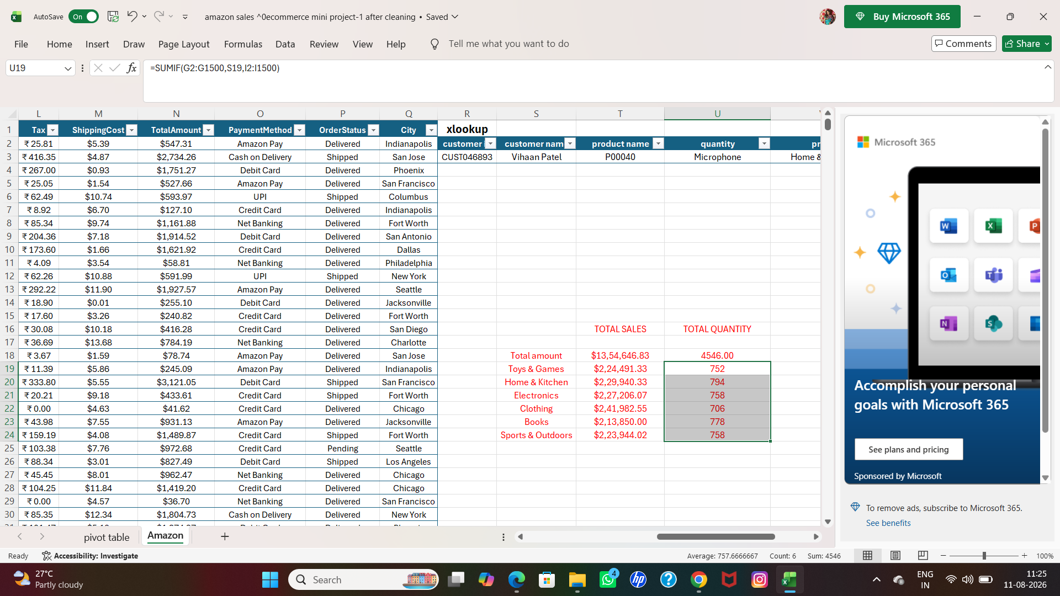

- Then I had to use look up function for the record.
- The formula i had given is
- =XLOOKUP([@[customer id]],C2:C1500,D2:D1500,0,0,1)
- At first i had chose R,S,T,U,V,W
Column
- Then I had to type customer id, customer name,product name,category,brand,quantity,unit price.
- Whenever I change the customer id ,the total column has changed as per query automatically.
- Then the result is shown

SCREENSHOT

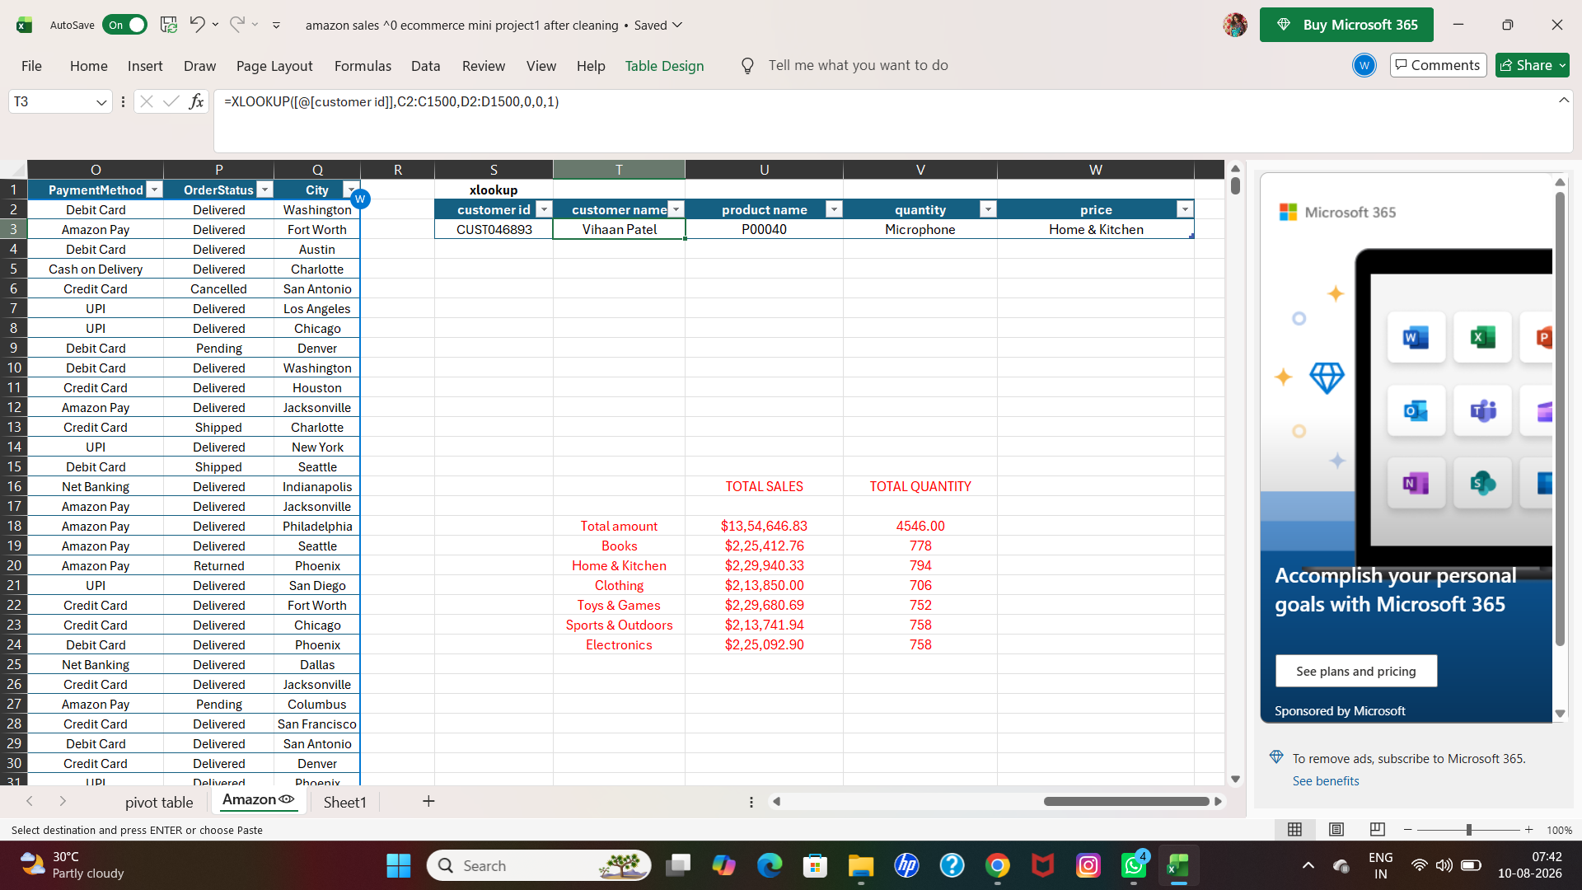

SCREENSHOT

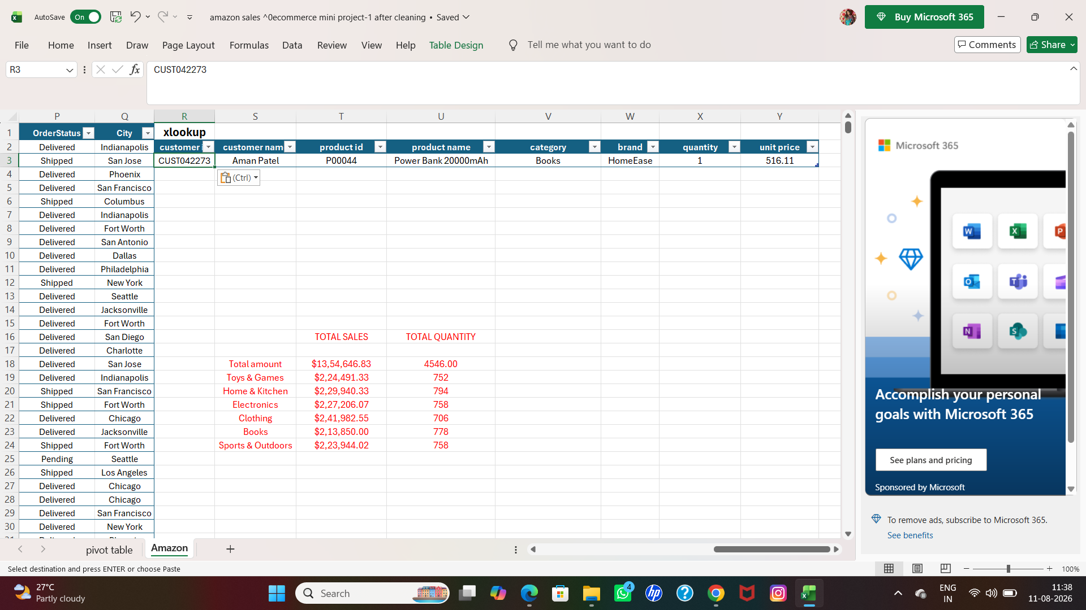

Q5■ Filtering and sorting

- For the filter option ,I had to choose one of the columns,named category.
- I left clicked on the header for filter the option,
- I had chose electronics for the filter
- Then the result shown

BEFORE
SCREENSHOT

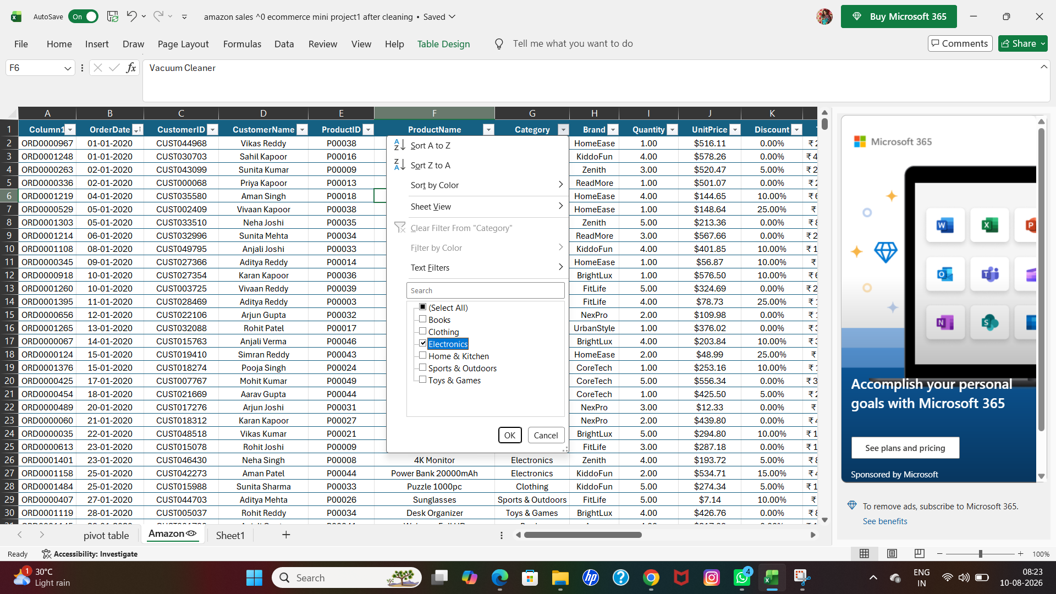

AFTER
SCREENSHOT

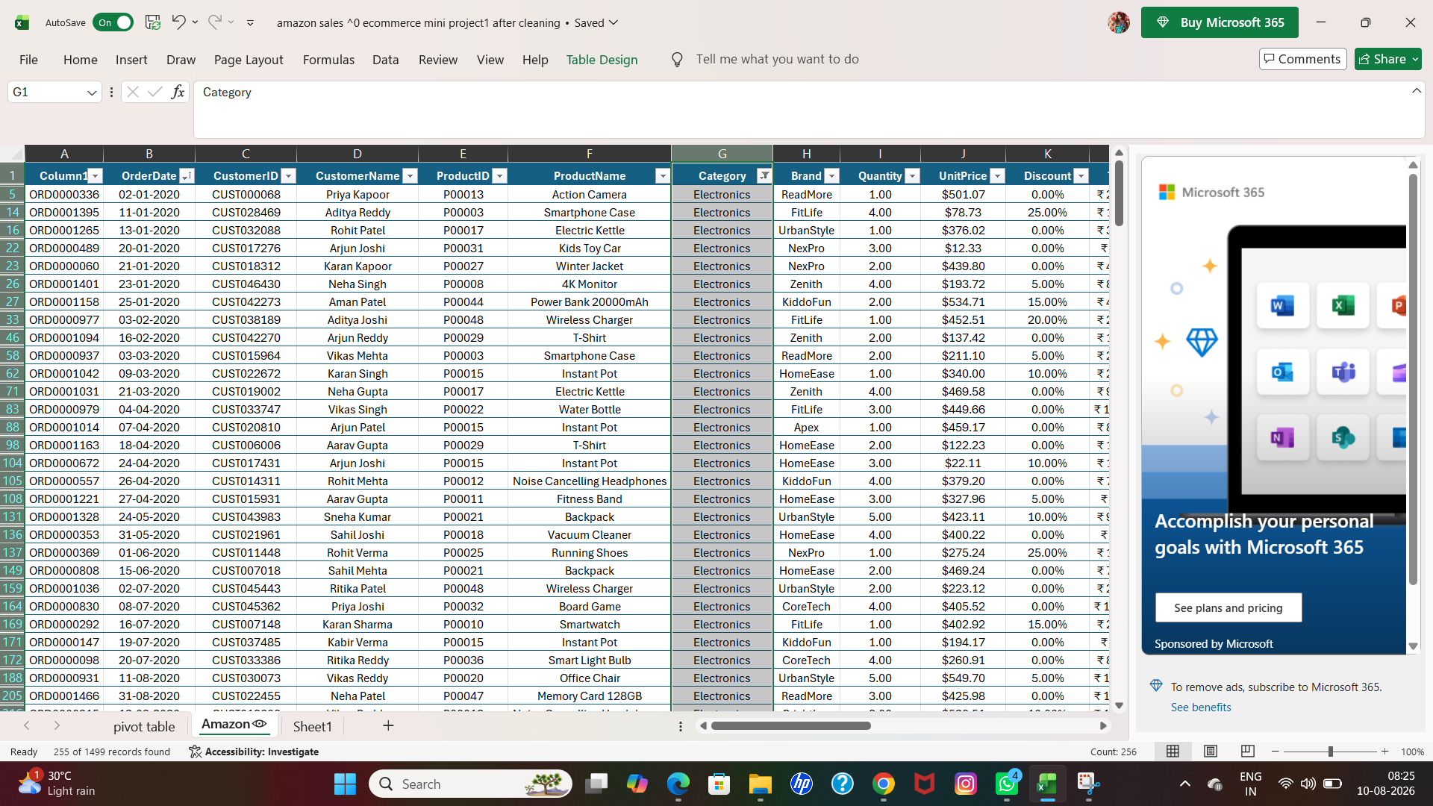

- Then for the sorting option, I had to click the right side on the header.
- Chose ascending for date sorting A to Z
- Then the result is shown

BEFORE
SCREENSHOT

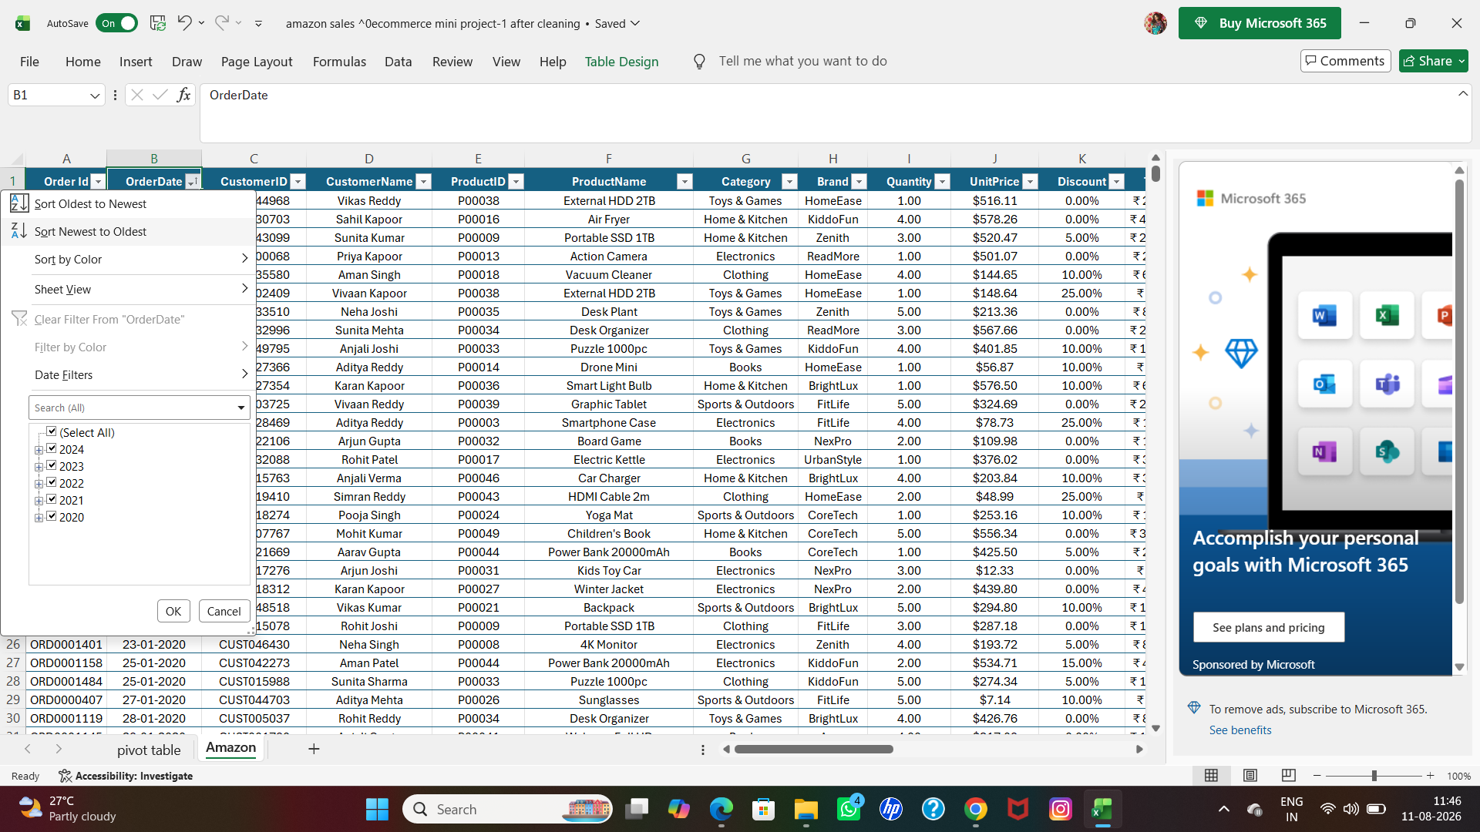

AFTER
SCREENSHOT

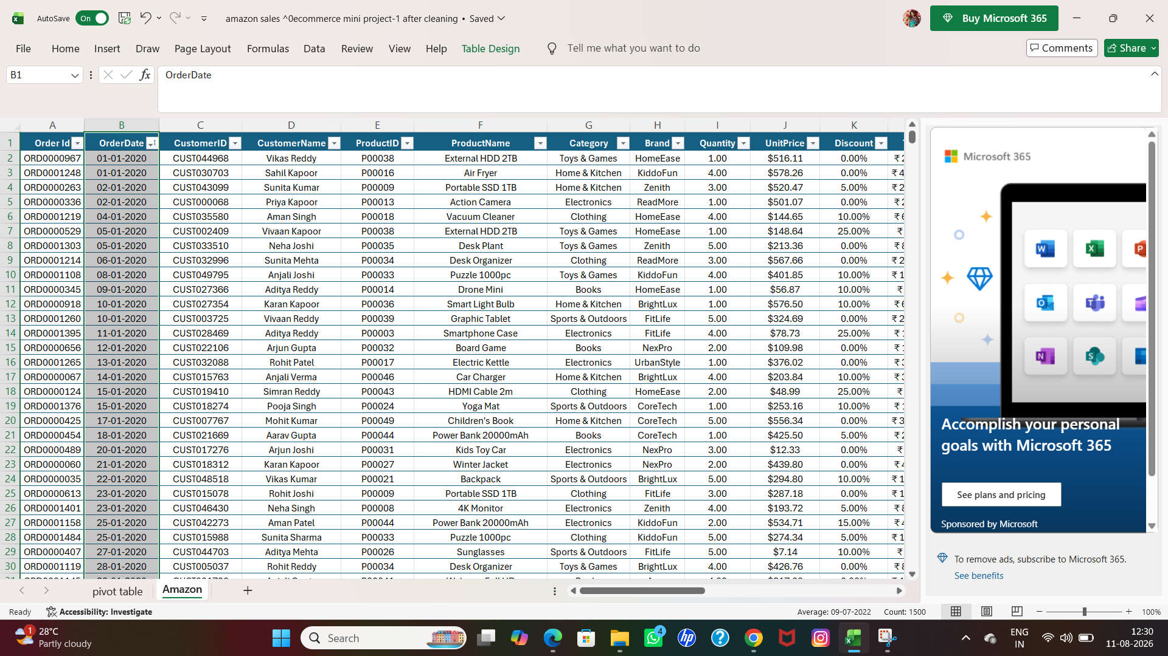

Q6■ Creating Pivot Tables (if required)

- I had to create pivot tables as per requirements.
- Go to insert option-select pivot table -then fulfil the requirements.
- For the first pivot table,I used category wise sales,sum of quantity,sum of price.
- Then the result is shown

SCREENSHOT

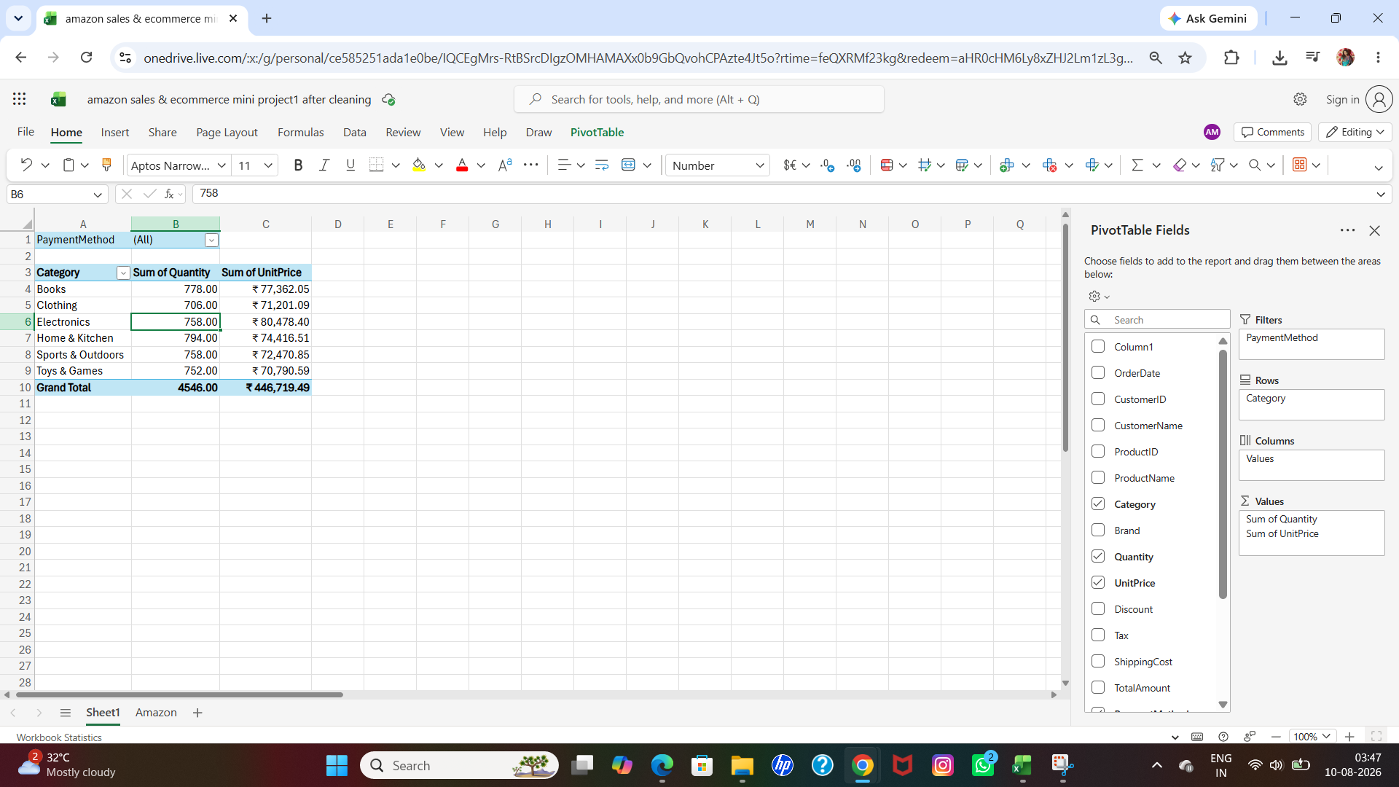

- For the second pivot table,i had to used brand wise sales,sum of quantity,sum of price
- Then the result is shown

SCREENSHOT

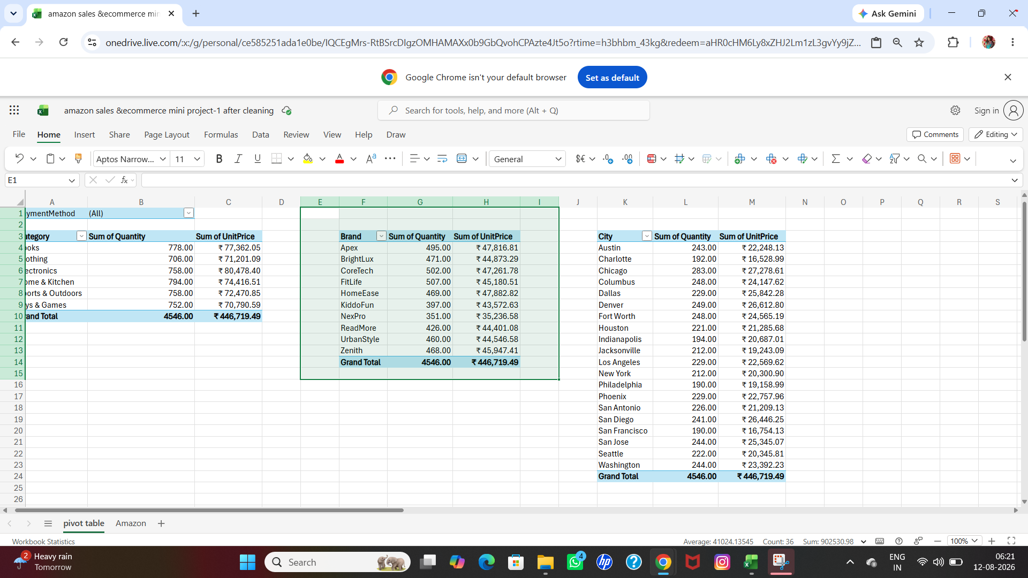

- For the third table,i had used city wise sales,sum of quantity,sum of sales
- Then the result is shown

SCREENSHOT

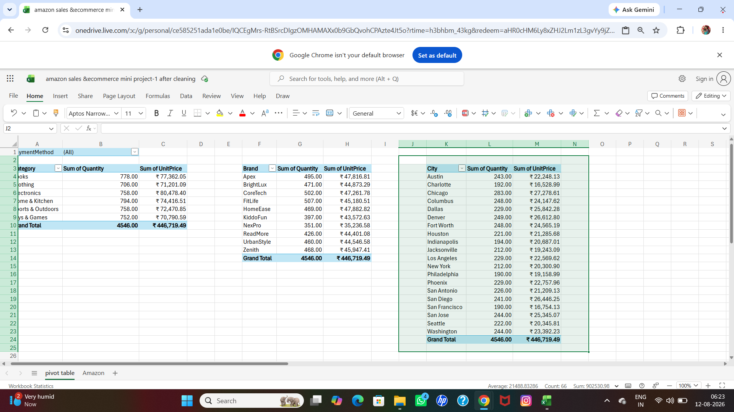

Powerbi Report
Amazon retail sales report for mini project 1

Data Analytics Mini Project Guidelines
Project Title -Amazon sales & ecommerce retail report
Name:Abinaya Mondal
Date of Submission:15/08/2026 B.No:22
Link:amazon retail sales report on mini project.pbix
Problem statement:

- I have an Amazon sales &ecommerce data set.
- My data set contains 1500 customer details.
- Totally 17 columns are there

- Q-First i have to find and remove the duplicates
- Left click of the header of the table -keep duplicates
- But i have no duplicates
- Here is the proof

SCREENSHOT
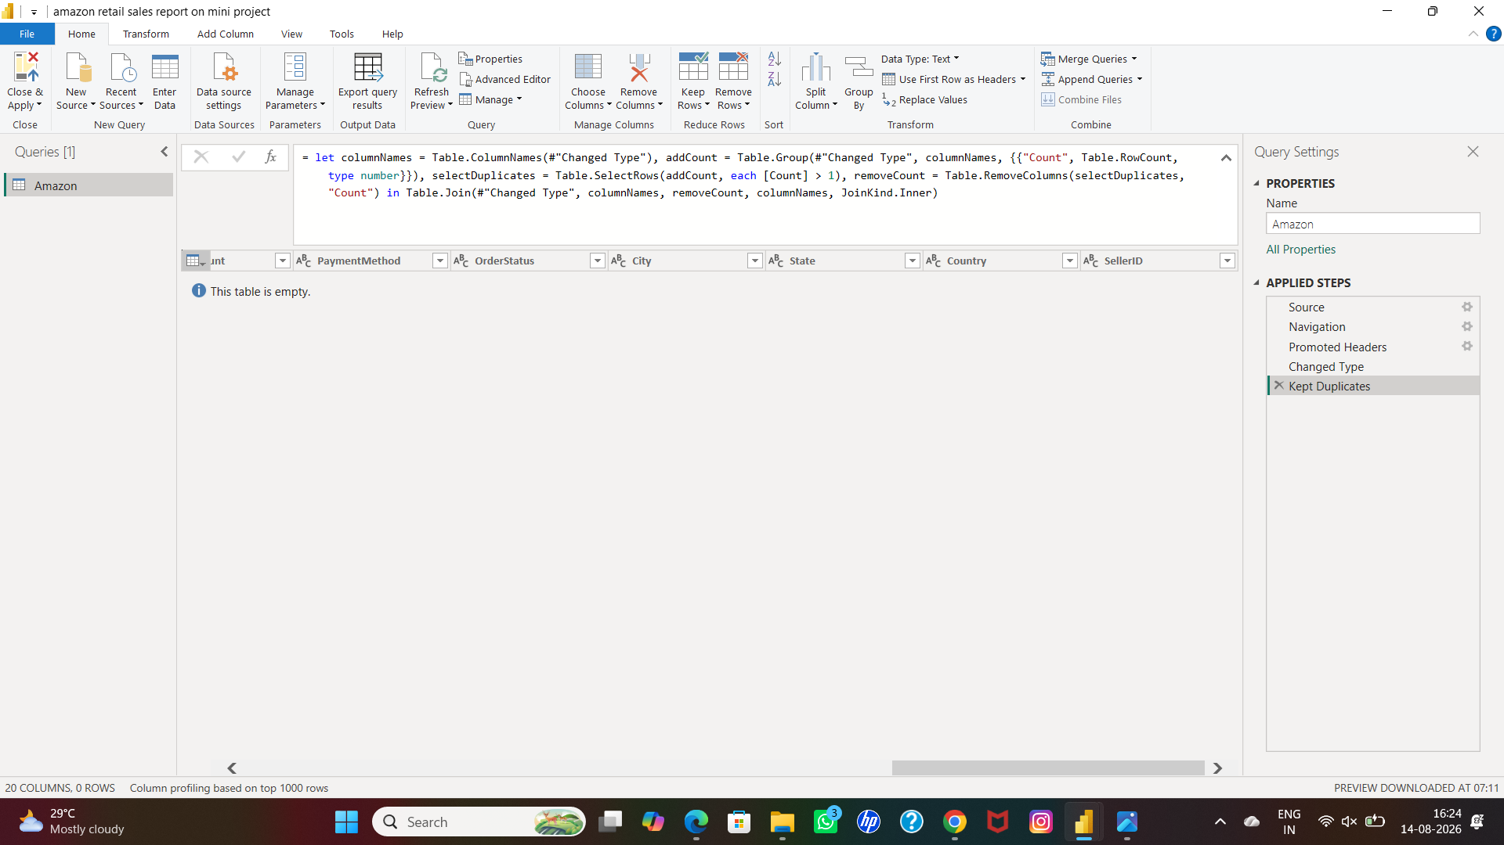

- Q-next I have to find the missing values.
- But as per my excel solution there are no missing values in it.

- Q-next I want to create the conditional column.
- The condition is if the total amount is >than 1000 then output is low margin.
- If the total amount is equal to 1000,then output is moderate margin .
- If the total amount is <than 1000 ,the output is high margin.
- Here is the proof

SCREENSHOT

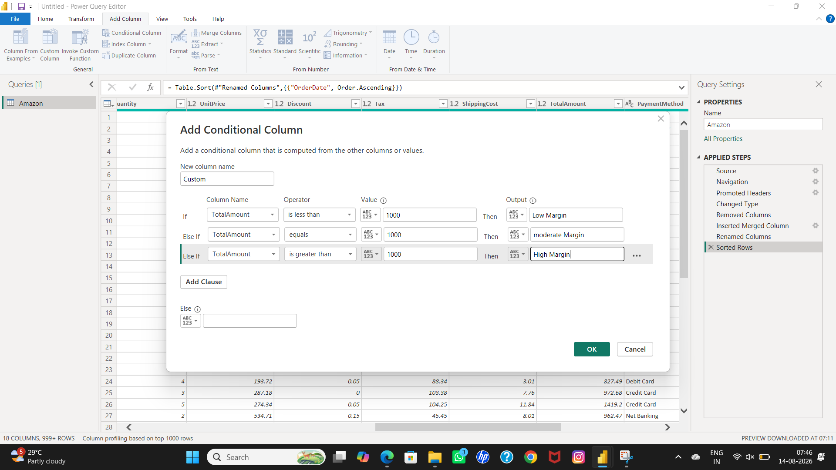

- Then I have to change the new column name as per query.
- Left click on the header-select rename option
- Then type the name

SCREENSHOT

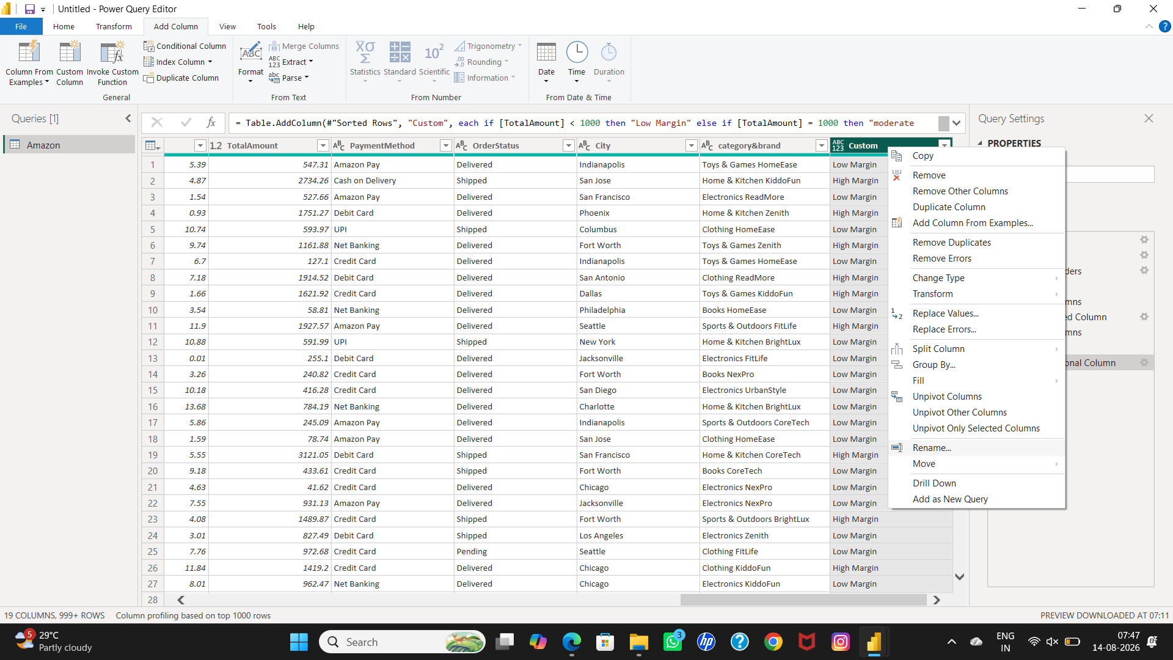

- Q-then i have to sort the row.
- I have to select the column by right clicking on the header..
- Then choose the option named sort ascending and sort descending as per need.
- Here is the result.

SCREENSHOT

- 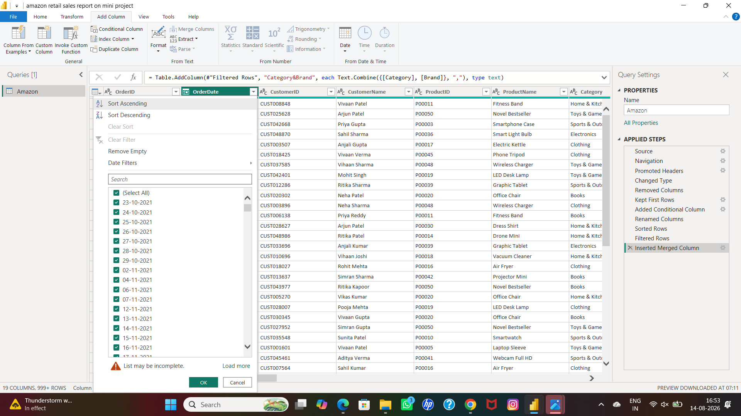

    - Q-then i have to filter the row as per need.
    - I just select the table by left click on header
    - Then i choose customer name column
    - Left click on the header
- Choose any one customer or two or as many as you want.
- Here is the result

SCREENSHOT

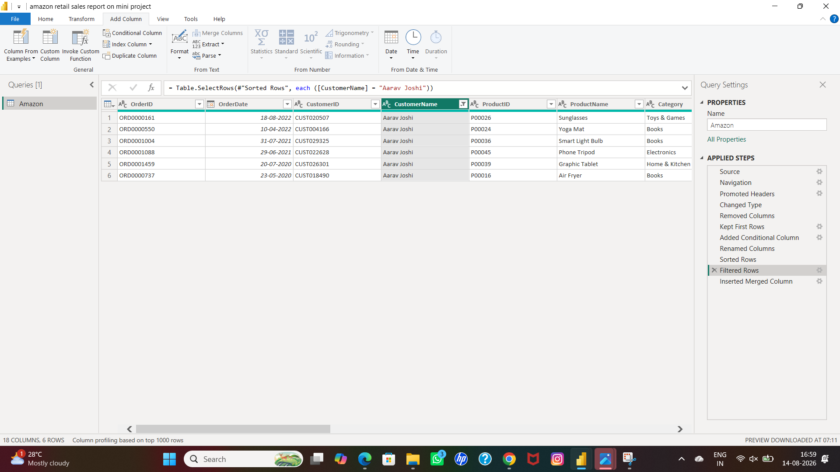

- Q-then I am going to merge two columns in one.
- By selecting two needed columns,shift+enter
- Then I need to fill up the query as per need.
- I also named the new column category&brand.
- Here is the result.

SCREENSHOT

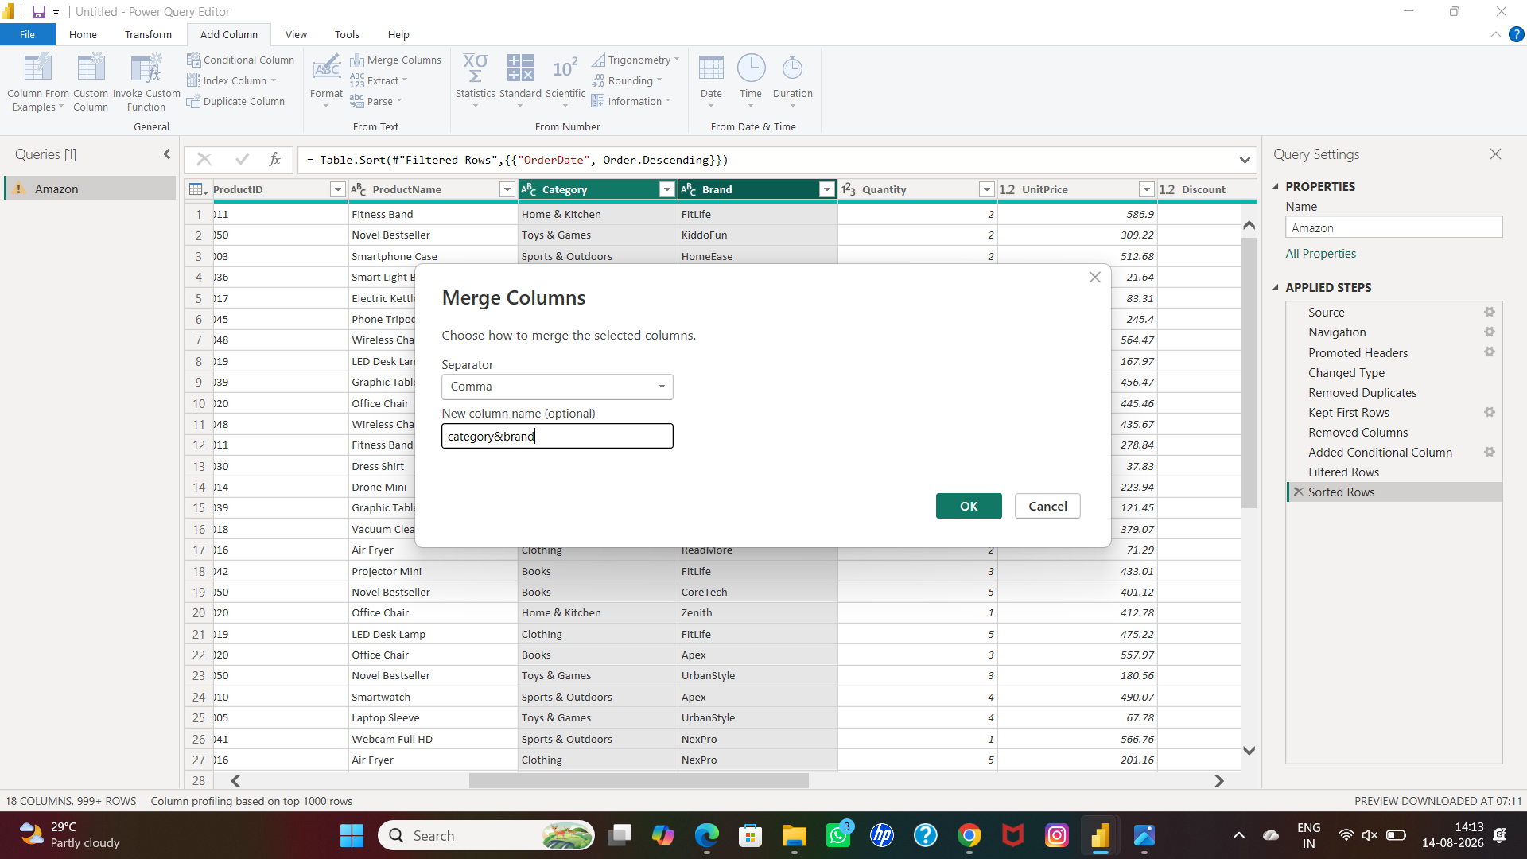

SCREENSHOT

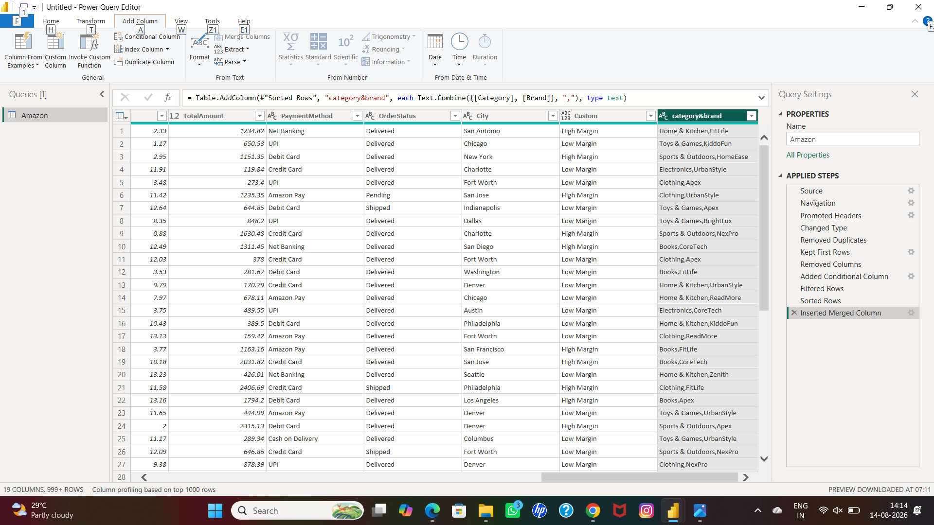

Q-next I am going to use the GROUP BY option for many useful contents.
Go to home-GROUP BY-fill up the query as per need
Here is the proof.
CATEGORY WISE SALES
SCREENSHOT

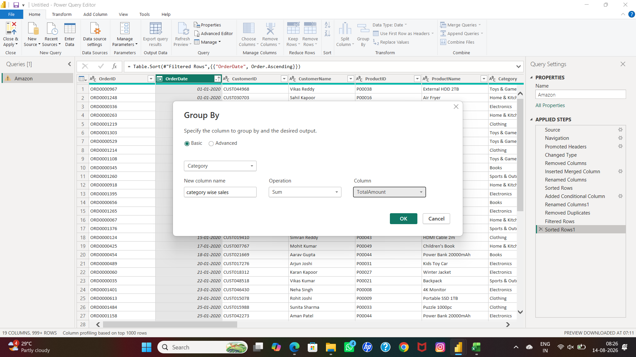

SCREENSHOT

- 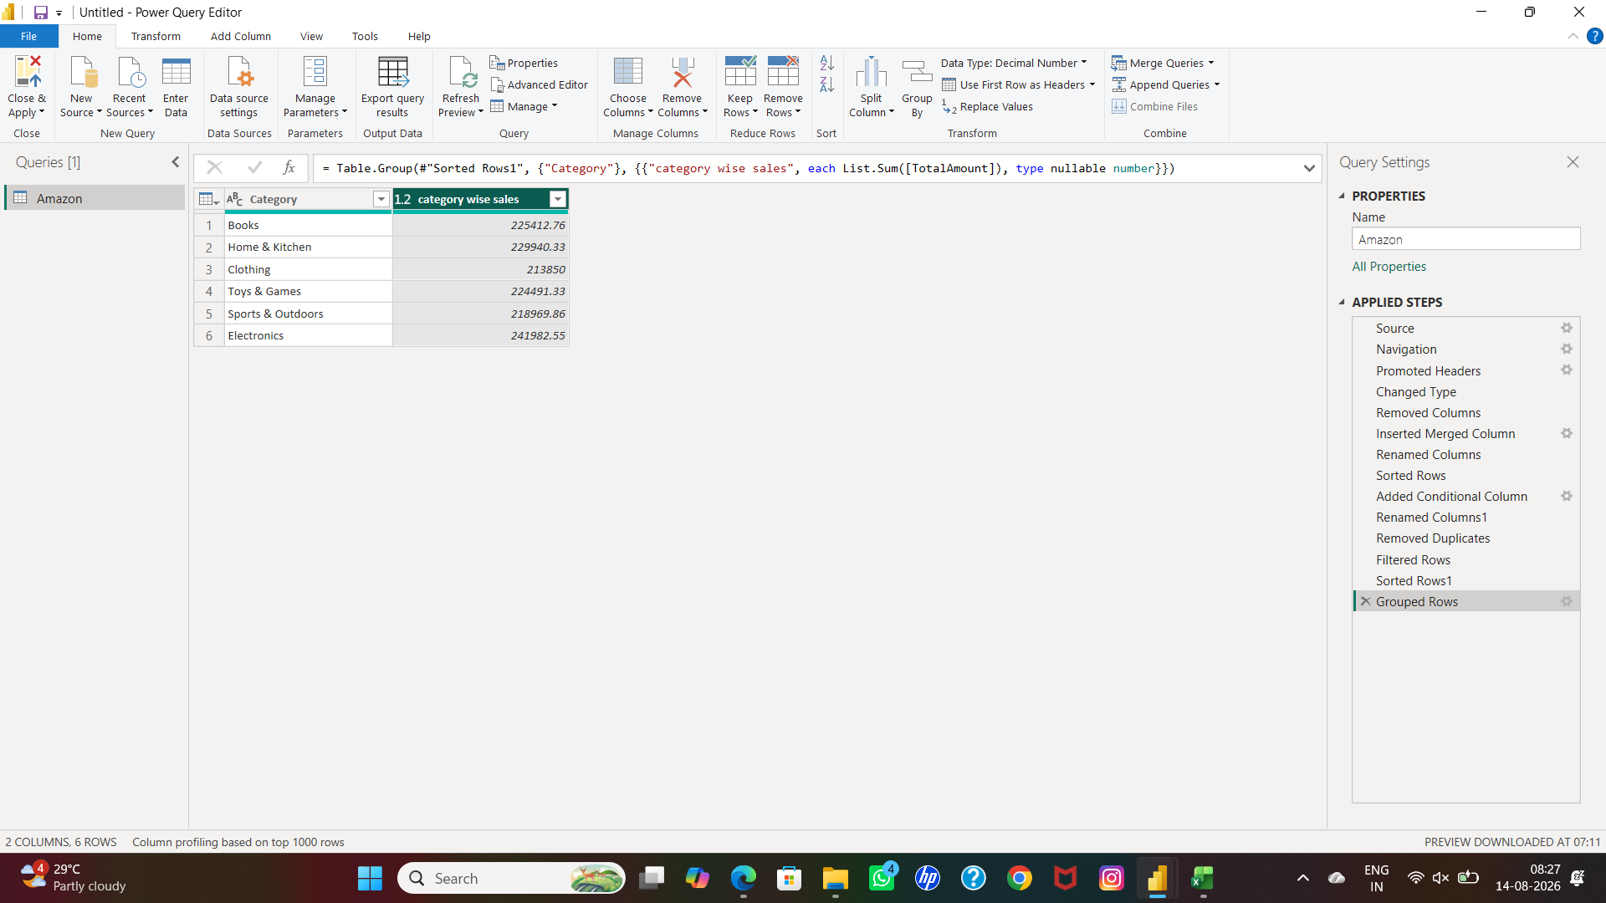
CUSTOMER WISE SALES

SCREENSHOT
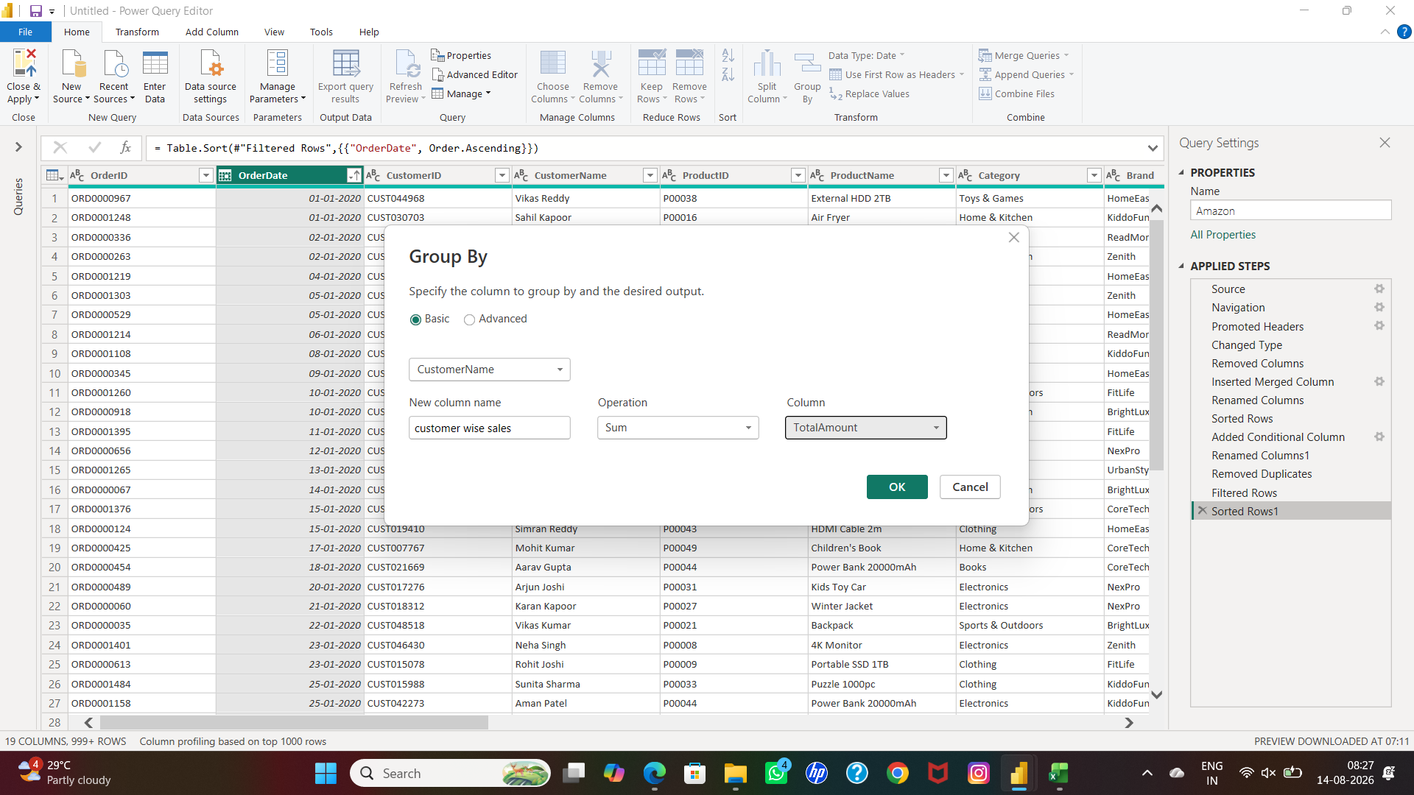

SCREENSHOT

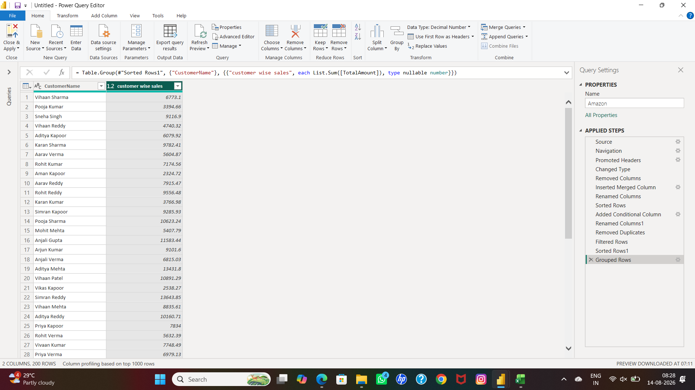

- Q-i just need to check how many Dax measures have been used for this table.
- By using this dax formula on DAX query view

// select "RUN"to try this sample dax query.
EVALUATE

INFO.MEASURES
()

- By simply giving this code you can see how many DAX functions are used by.
- You can select how many columns you want on this new table named NT.
- Here are the results

SCREENSHOT

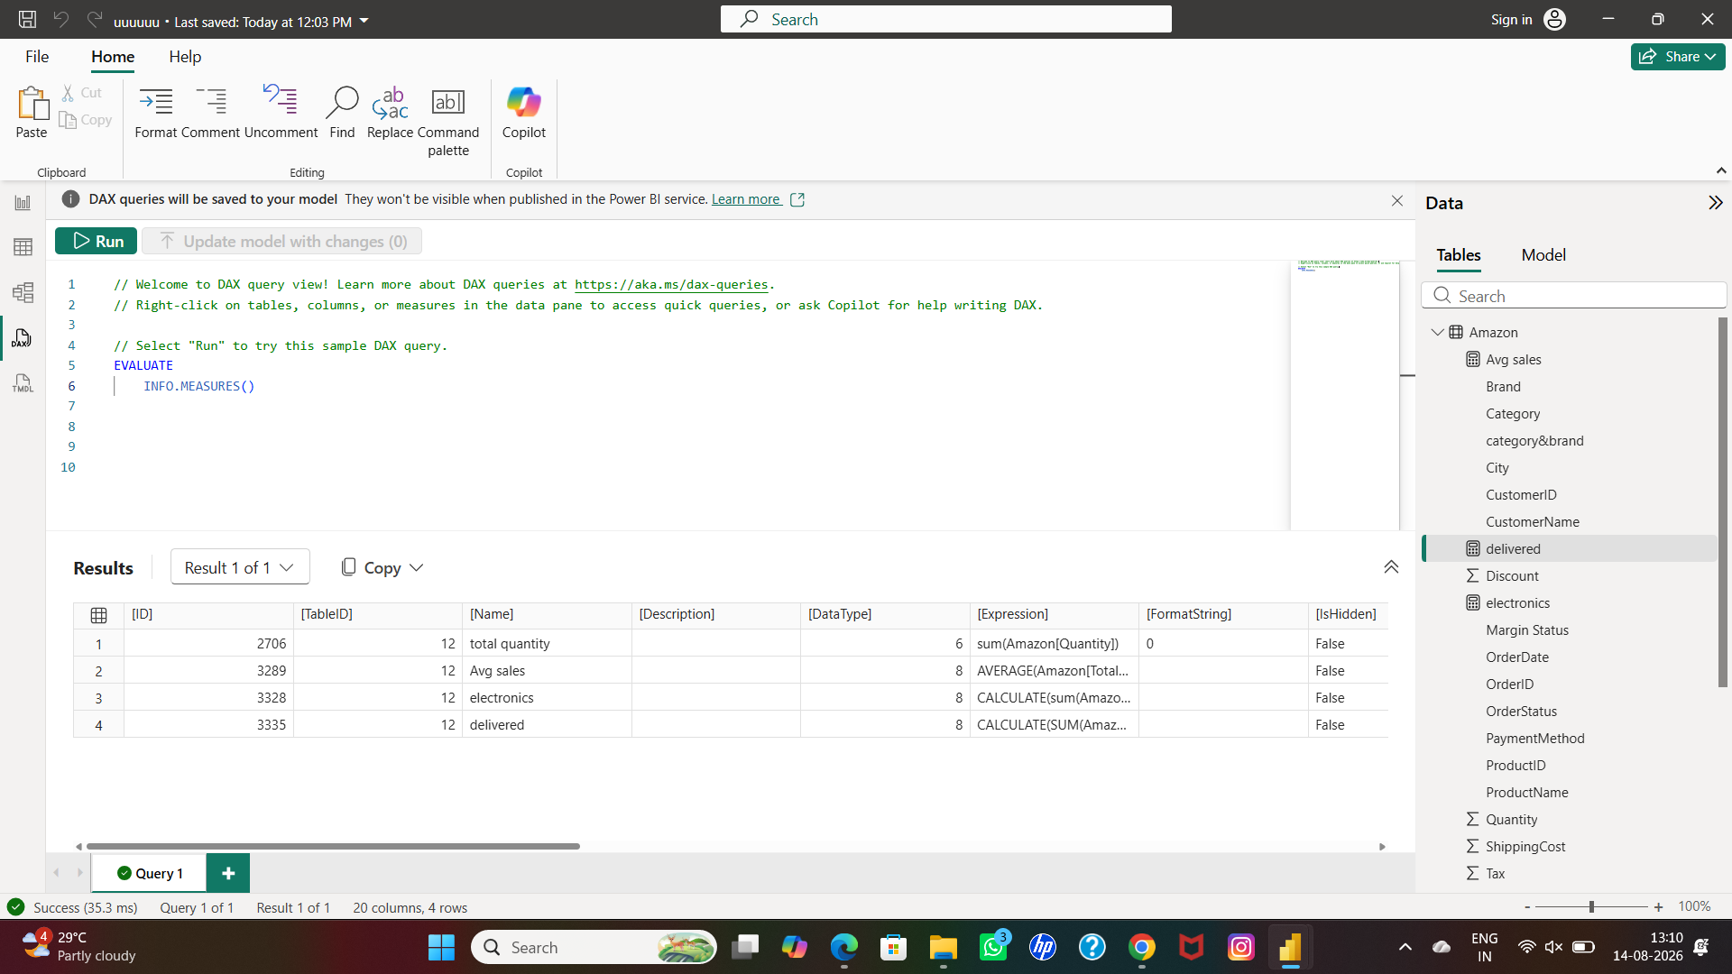

FOR NEW TABLE

- I had used this formula for creating new calendar table
- NT = ALLSELECTED(Amazon[CustomerID],Amazon[CustomerName],Amazon[Brand],Amazon[Category],Amazon[OrderDate])
- Here are the results

SCREENSHOT

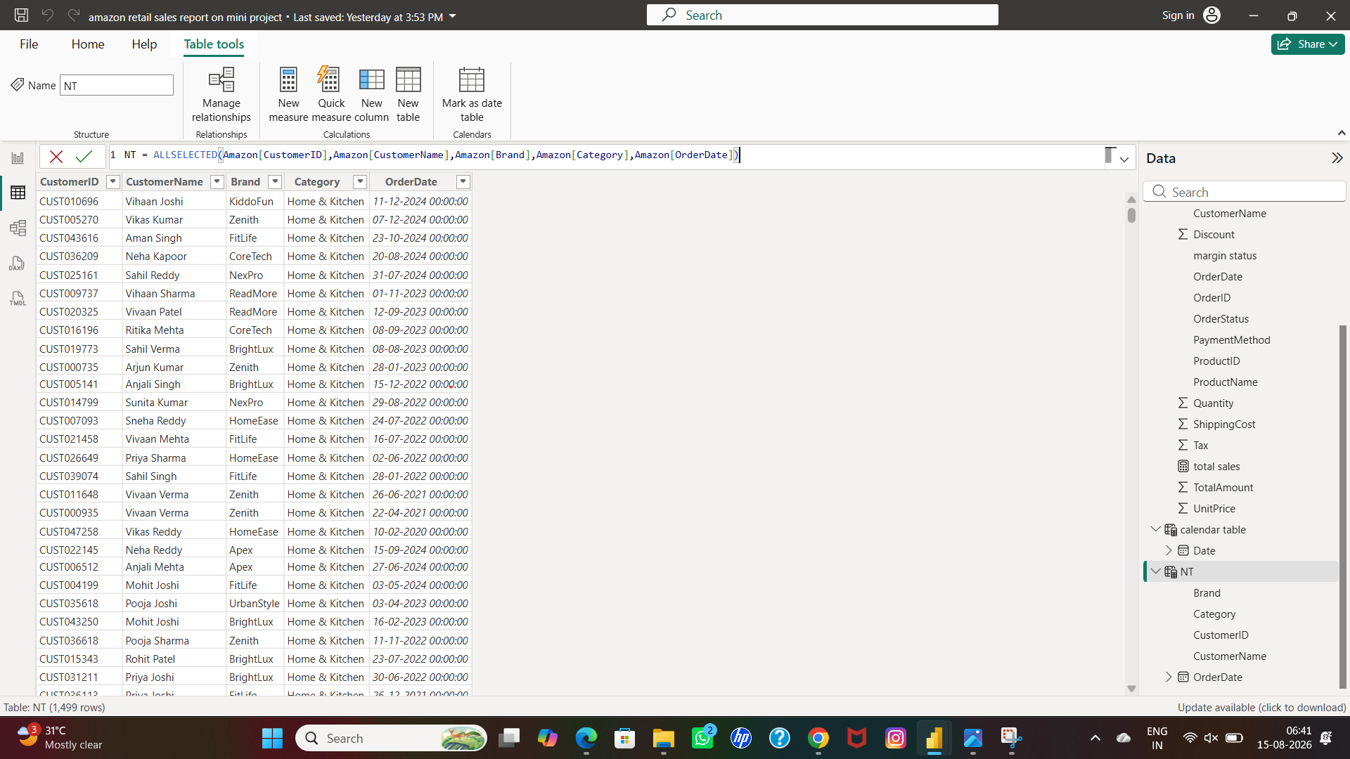

Now we have three tables
1.amazon
2.calendar table
3.NT

  - We have to create new relationship between them

- GO TO model view
- First we have to create a relationship between the NT table and Amazon table.
- By dragging the common factors between two tables.
- Then a new relationship box opens to fill up for the needful information.

- The relationship between amazon table and NT table only can select many to many relationship option
- Because NT table is copy of Amazon table so,
- Here is the proof.

SCREENSHOT

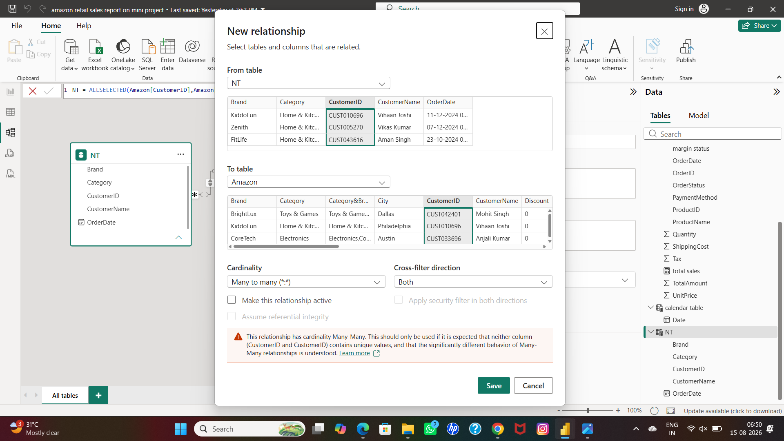

SCREENSHOT

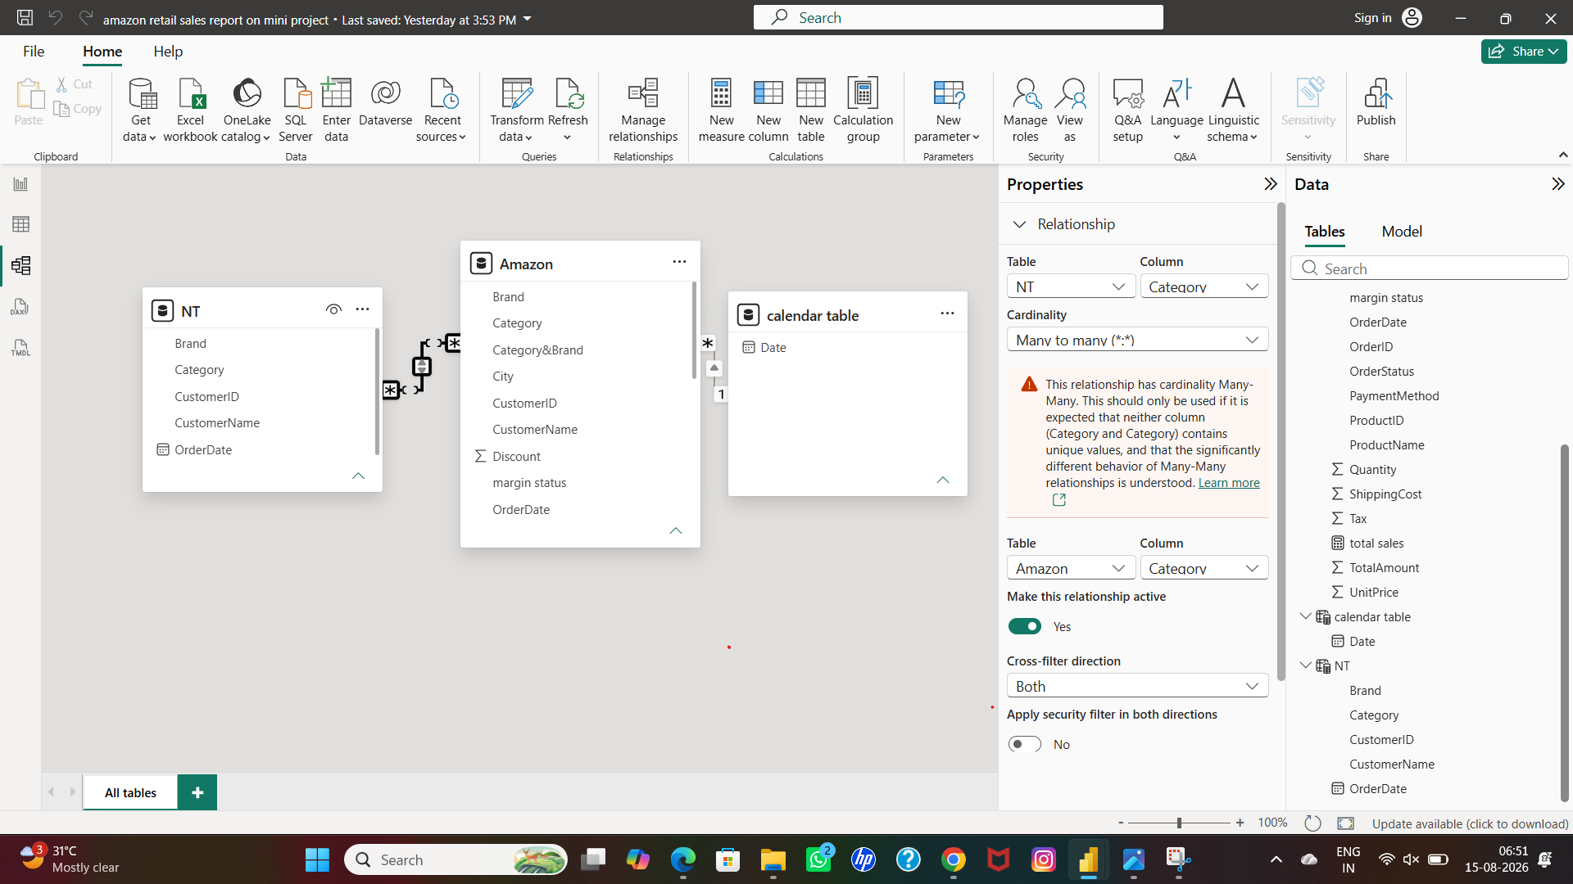

- Then we have to create new relationship between Amazon table and calendar table
- By dragging the common factors between the two table
- A new relationship box open
- Have to select common column
- But this two tables only can have many to one relationship because calendar table have only order date data source
- Here are the proof

SCREENSHOT

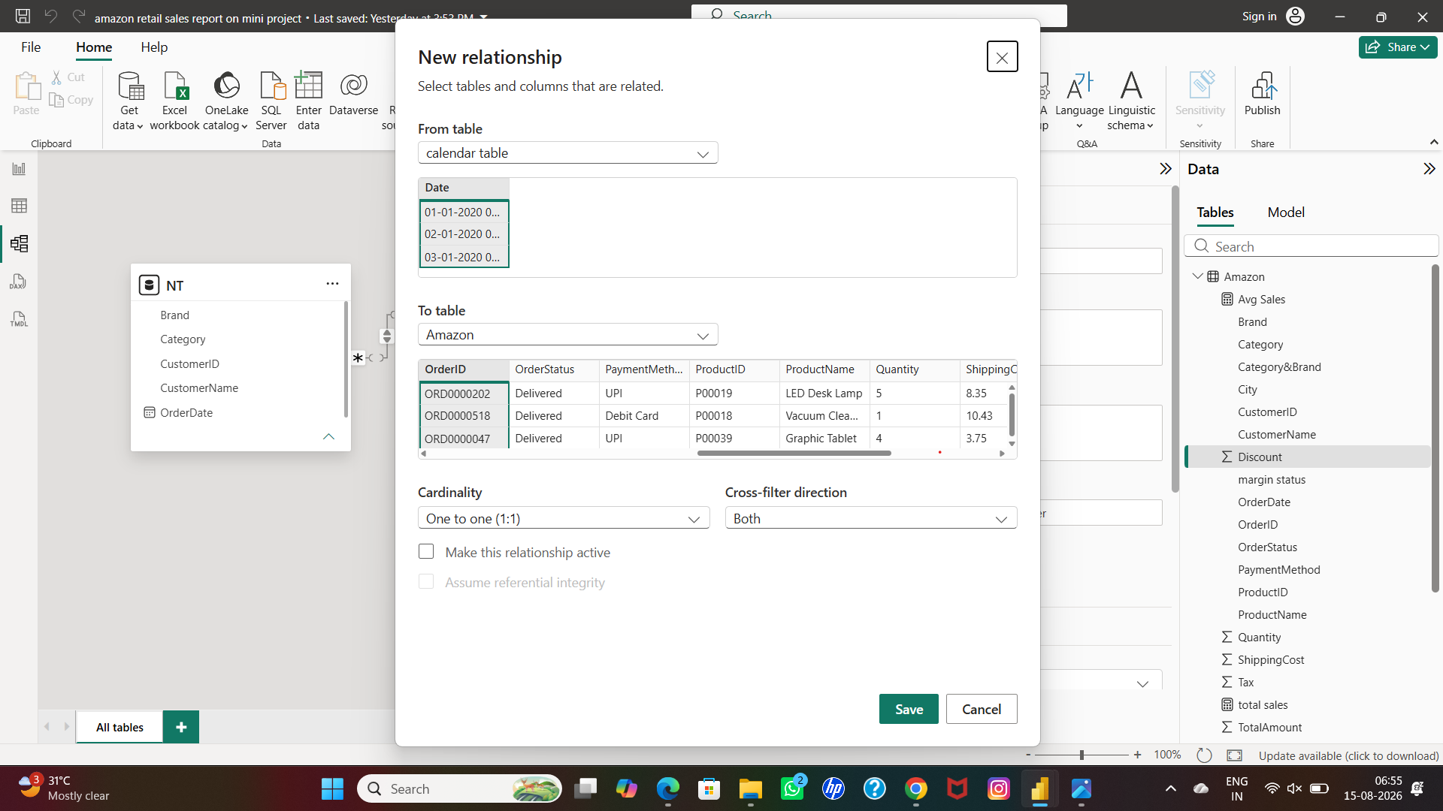

SCREENSHOT

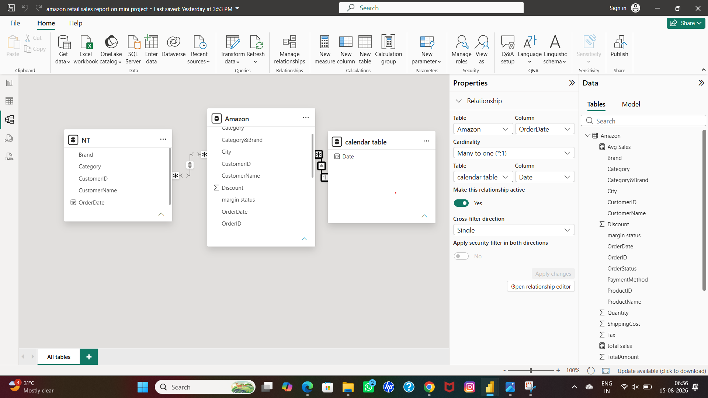

- After created the relationship,move to Amazon sales report dashboard creation
- First I have create, total sales amount and total sales quantity report by using a line chart.
- For the data source we have to use dax measures formula

- Total sales=sum(Amazon(total amount))
- Total quantity=sum(Amazon(quantity))

- Then for visualization
- Click visualization -go to format visual-general-title
- For title card and font size changes.

- Click visualization -go to format visual-general-effects
- For background color

- For next chart-pie chart
- Select data source from the three tables already organized,
- From this pie chart-total sales and brand.

- Then for visualization
- Click visualization -go to format visual-general-title
- For title card and font size changes.

- Click visualization -go to format visual-general-effects
- For background color.

- For next chart-clustered bar chart
- Select data source from the three tables already organized,
- For this bar chart,Total sales by category wise.

- Then for visualization
- Click visualization -go to format visual-general-title
- For title card and font size changes.

- Click visualization -go to format visual-general-effects
- For background color.

- For next chart,used slicers
- For the slicers-total sales amount by city wise report
- Select data source from the three tables already organized,

- Then for visualization
- Click visualization -go to format visual-general-title
- For title card and font size changes.

- Click visualization -go to format visual-general-effects
- For background color.

- For the next chart-cracked bar chart
- For the data source of cracked bar chart by using the information
- Total sales amount by year wise
- Select data source from the three tables already organized,

- Then for visualization
- Click visualization -go to format visual-general-title
- For title card and font size changes.

- Click visualization -go to format visual-general-effects
- For background color.
- For the next chart,cards are used by
- Multiple cards using by the information of
TOTAL SALES,AVG SALES,SUM OF QUANTITY

FORMULA USED BY DAX MEASURES

Total sales=sum(Amazon(total amount))

Avg sales=average(Amazon(quantity))

Total quantity=sum(Amazon(quantity))

Here is the proof

SCREENSHOT

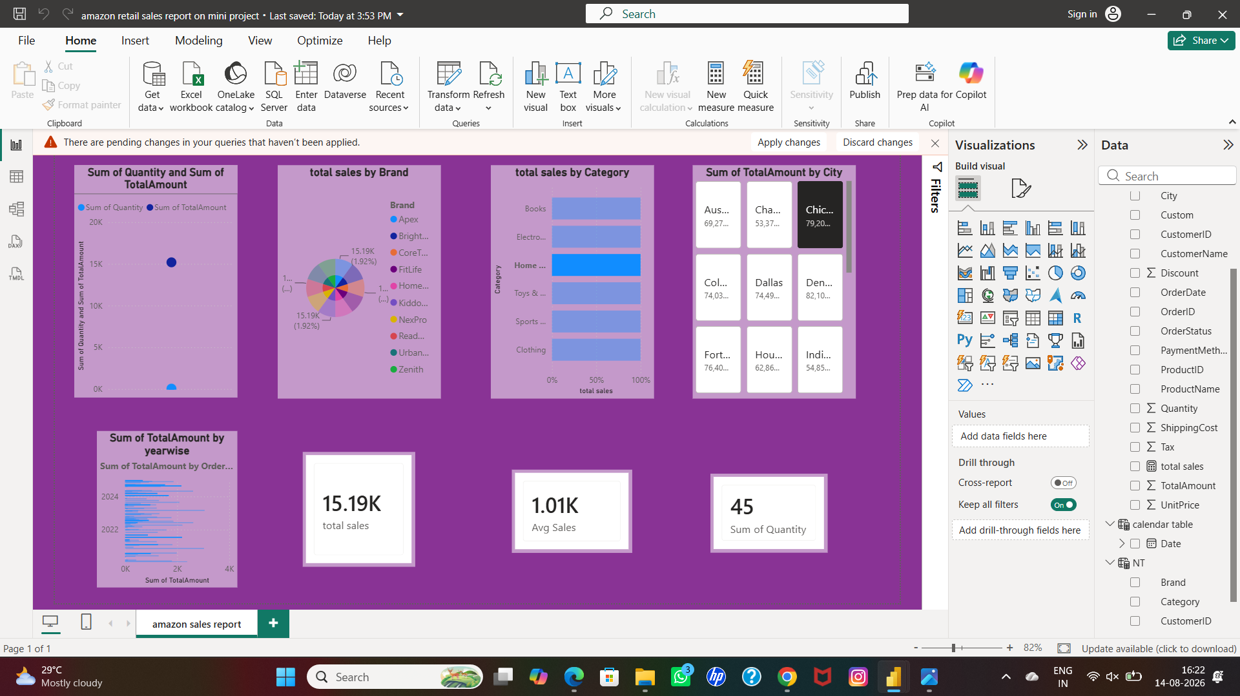

COMPLETE AMAZON SALES REPORT READY TO VIEW

